ACAS
Applewood Computers Accounting System

Purchase Ledger

Reference Manual

v3.3

This document is the Reference manual for Applewood Computers Purchase Ledger System which in turn is part of ACAS system components which is the Applewood Computers Accounting System and is :
Copyright © Applewood Computers and Vincent B Coen 1980 - 2025 and later.

Which Includes :
*IRS – Incomplete Records System (used in place of GL)
*Nominal or General Ledger also referred to as GL
*Sales Ledger also known as Accounts Receivable and as SL
*Purchase Ledger also known as Accounts Payable and PL
*Invoicing (module/s added into Sales and Purchase Ledger)
*Stock Control also known as Inventory with links to Sales & Purchase

An old version of Payroll written in CBasic around 1981 is available as source
in folder basic-code but it was written for the USA market and will need some
changes. to work with the Free Basic Compiler (FBC).

Items identified by a star (*) are now Open Source packages.
This and the accompanying documents relate, to these Open Source packages.

Each sub system has its own documentation.

Applewood Computers
17 Stag Green Avenue
Hatfield
Hertfordshire
AL9 5EB
United Kingdom

Lead Programmer Email: vbcoen@gmail.com

Support Email: vbcoen@gmail.com
Website: www.sourceforge.net/p/acas

Copyright © 1980 – 2025 Applewood Computers

WARNING: This manual is still being rewritten as the ACAS package is being updated and tested for the current Cobol based system. It was created using the Sale Ledger manual.
Some figures (menu and report items) have not been included - System testing will allow these to be added. Currently in progress (September 2025))

Author: Vincent Coen, The author asserts his copyright over this work.
Document update: 18. September 2025
Revision: 46
Software Version Date: September 2025 and nightly builds
Software Version 3.3 and for v3.2.
Word Processor: LibreOffice 24.2

1 3 5 7 9 0 2 4 6 8
Contents
1. Overview 1
1.1. Using the Documentation 1
1.2. The Operating System. 3
1.3. Cobol 3
1.4. Facilities Overview 5
1.4.1 System Configuration 5
1.4.2 Using the System 7
1.4.3 Responding to the System 7
1.4.4 PL System Facilities 9
1.4.4.1. Date Entry - Option A 9
1.4.4.2. Supplier File Maintenance - Option B 9
1.4.4.3. Purchase Ledger Enquiry - Option C 10
1.4.4.4. Purchase Transaction Input, Amend, Delete - Options D, E & F 10
1.4.4.5. Purchase Transactions Proof - Option G 10
1.4.4.6. Purchase Transactions Post - Option H 10
1.4.4.7. [Manual] Payment Input, Amend, Proof and Post - Option I, J, K & L 10
1.4.4.8. Set-Up Purchase Analysis Codes - Option M 10
1.4.4.9. Purchase Analysis Reporting - Option N 10
1.4.4.10. Purchase Day Book - Option O 10
1.4.4.11. Aged Creditors Report - Option P 11
1.4.4.12. Alphabetical Suppliers List - Option Q 11
1.4.4.13. Supplier Turnover Report - Option R 11
1.4.4.14. Payments System - Option S 11
1.4.4.15. End of Cycle Processing - Option T 11
1.4.4.16. Transaction Sub-System - Option U 11
1.4.4.17. Supplier File Dump - Option V 11
1.4.4.18. Exit to O/S - Option X 11
1.4.4.19. System Set Up - Option Z 11
1.4.4.20. Purchase Analysis & Purchase Statistics 12
1.4.4.21. IRS / General Ledger Interface 12
1.4.4.22. Line / Stock Item Accounting 12
1.4.4.23. Purchase Reporting 12
1.4.4.24. Adjustments / Credit Notes 12
1.4.4.25. Autogen (Recurring purchase orders) - Optional and not yet available 12
1.4.4.26. Purchase Order Production 13
1.5. Operating Summary 14
1.5.1 Steps 1, 2, 3 14
1.5.2 Step 4 14
1.5.3 Step 5 15
1.5.4 Steps 6 and 7 15
1.5.5 Step 8 15
1.5.6 Step 9 15
1.5.7 Step 10 15
1.5.8 Step 11 15
1.5.9 Step 12 16
1.6. Operating Detail 17
1.7. Using the Entry programs 21
1.8. Using the Print programs 21
2. System Set Up 22
2.1. The System and Parameter Files Set up - Option Z 22
2.2. Sample ACAS Parameter File Set up Report 38
2.3. Analysis Recording and Reporting Set up - option L. 40
2.4. The General Ledger Interface 42
2.5. The Supplier Record - option B. 43
2.6. The Supplier Print programs 44
3. Order Transactions 49
3.1. The Order Transactions Batch 49
3.1.1 Prerequisite Settings 49
3.2. The Transaction Proof - option G. 55
3.3. Posting the Transaction Batch - option G. 57
3.4. The Payment Batch (manual processing) 58
3.5. The Payment Proof. 59
3.6. Posting the Payment Batch 61
3.7. Recurring Purchase Orders - options U, 9 62
3.7.1 Entering Recurring Purchases (PL810) 62
3.7.2 Proofing the AutoGen File - PL820 63
3.7.3 Auto-Generating and Posting orders - PL830 63
4. Pre and Post Applied Reports 65
4.1. The Aged Trial Balance / Aged Creditor Analysis Reports - option P 65
5. Payment System (auto) 67
5.1. Generate Payments to be made - Option 1 67
5.2. Amend Payments - Option 2 67
5.3. Proof Payments - Option 3 67
5.4. Generate Payments - Option 4 67
5.5. Print Payments Register - Option 5 68
5.6. Print Remittance Advices - Option 6 68
5.6.1 send-some-mail.cbl 68
5.6.2 send-some-mail2.cbl 68
5.6.3 send-mail-test-example.cbl 68
5.7. The On-Line Enquiry 69
6. Operations 70
6.1. Option A - Date Input - PL000. 70
6.2. Option B - Supplier File Maintenance (Data Entry) - PL010. 70
6.3. Option C - Purchase Ledger Enquiry - PL015. 70
6.4. Option D - Purchase Transactions Input - PL020. 70
6.5. Option E - Purchase Transactions Amend - PL030. 70
6.6. Option F - Purchase Transactions Delete PL040. 71
6.7. Option G - Purchase Transactions Proof PL050. 71
6.8. Option H - Purchase Transactions Post - PL060. 71
6.9. Option I - Payment Input - PL080 - Manual Mode. 71
6.10. Option J - Payment Amend - PL085. 71
6.11. Option K - Payment Proof - PL095. 71
6.12. Option L - Payment Post - PL100. 71
6.13. Option M - Set-Up Purchase Analysis Codes - PL070. 71
6.14. Option N - Purchase Analysis Report - PL130. 71
6.15. Option O - Purchase Day Book - PL140. 71
6.16. Option P - Aged Creditors Analysis - PL120. 71
6.17. Option Q - Alphabetical Supplier List - PL160. 71
6.18. Option R - Supplier Turnover Report - PL170. 72
6.19. Option S - Payment (semi automated) system - PL900 72
6.19.1 Option 1 - Generate payments to be made - PL910 72
6.19.2 Option 2 - Amend payments - PL920 73
6.19.3 Option 3 - Proof payments - PL930 73
6.19.4 Option 4 - Generate Payments - PL940 73
6.19.5 Option 5 - Print Payment Register. 73
6.19.6 Option 6 - Print Remittance Advices. 73
6.19.7 Option X - Return To System menu 73
6.20. Option T - End of Cycle processing - XL150 73
6.21. Option U - Transaction Sub-System - PL900 73
6.21.1 Option 1 - Amend Invoicing Fixed Data 73
6.21.2 9. Recurring Transaction Processing. 74
6.21.2.1. Option 1 - Enter / Amend Recurring orders - PL810 74
6.21.2.2. Option 2 - Proof Recurring Orders - PL820 74
6.21.2.3. Option 3 - Post Recurring Orders - PL830 75
6.22. Option V - Supplier File Dump - PL190 76
7. ACAS System wide File and RDBMS Table Usage Chart 77
8. Individual file details where needed. 79
8.1. ACAS System file 79
9. Reporting problems with ACAS products 81
10. Error messages used within the ACAS system 82
10.1. Cobol and C Error Messages 82
10.2. ACAS Error Messages 82
10.3. SSDs and Garbage Collection. 83
11. Purchase Ledger Error Messages 85
11.1. ACAS System wide Messages 86
11.1.1 From FH (the Cobol File Handlers) 87
11.1.2 From DAL (the RDBMS Data Access Layer) 87
11.1.3 From FH-and DAL Logger (During Testing only) 88
11.2. System wide Messages for Purchase 89
11.2.1 System wide Purchase FH ~(File Handlers) 89
11.2.2 System wide Purchase DAL (the RDBMS Data Access Layer) 89
11.2.3 Specific Purchase Messages by Program or program 90
11.3. File Access Error numbers 96
11.4. RDBMS error codes 97
11.5. MySQL SQL Status messages 97
12. Error Recovery 98
13. Scripts 99
13.1. acasbkup.sh 99
13.2. acasbkup-Pre-EOY.sh 100
13.3. acasbkup-Post-EOY.sh 101
14. Command Key Summary 102
15. Manual errors or omissions 103

Table of Figures

Once I find out how using LibreOffice writer.!

But if you know how, please drop me a note as to what to do, see inside front cover for email address.

This manual is under update during full system testing for v3.3.

This manual, like all of the ACAS manuals, may well have errors in grammar, detail or by absence or presence of information that does not match the software discussed.

Every endeavour is made to ensure accuracy, but manuals like software, can have bugs despite multiple readings of the same document. After a time, you end up with word blur so having others to read them helps. This statement is in general for all of the ACAS manuals but for P/L - it is still under update / revision mode.

If you find any faults, please report it along with any suggested changes, see inside front cover for email contact details. Please do not assume that others have done so.

It is recommended to also read the S/L manual as the processing is similar apart from Statement, late letter, Invoice production, etc.

Overview

Using the Documentation

This manual should be read in conjunction with the manual ACAS- Building the ACAS System and this one, should be read first, at least for an overview of the system.

The first sections of this manual presents an overview of the system and an explanation of how to run the various programs. The remainder devotes a chapter to each individual process or program in the system. later on is the process undertaken by each program on a program by program basis, see chapter 6, page 70.

References to programs, modules or processes should be accepted as the same thing in that they are separate units that act as a process or function as indicated from the menu. They in turn may call others as needed. Here consider that files and tables (for rdbms) mean the same in that they hold data for a given requirement. These are documented later in this manual and in the ACAS - Building the ACAS System manual. All references to Sales, Purchase, General / Nominal Ledgers - IRS and Stock Control, have the same meanings as Accounts Receivables, Accounts Payables, General Ledger, Inventory).

In many instances, Nominal is referred to as General depending on where it is presented, just depends on where you are from, but the former are normally the terms used in the United Kingdom and the later in North America although it can even differ in different part of the UK based on the profession of the user.

Read the overview before moving on to the rest of the manual. Read all the documentation thoroughly before setting up and running any of the programs.

After reading the documentation decide which of the optional features you desire. After making these decisions, re-read the operating summary before you begin entering real data.

You may find it beneficial to create a practice set of data first, before you invest time keying in real data as you may find that only some aspects of the system will need to be used to mate up to processing used within the business.

A practice company could consist of 10 to 15 suppliers, 10 - 20 stock items and 25 to 30 Purchase orders (or also called invoices in some places of both the software and this manual). Running through one or two accounting cycles (e.g., monthly, quarterly, etc.) with this data which will help to clarify the operating procedures.

If you are converting from a previously used system it is possible to transfer the data from the old system to ACAS. To do this, you will need to obtain details of that system including the file names and data layouts for each file used where ever possible, and pass them on to us. In the worse case scenario, a copy of all the data files and a printout (or .pdf) of each system report such as lists of suppliers, outstanding PO's (Purchase Orders or invoices, etc., as is available. You should contact us using the details on the inside front cover, detailing what you want to migrating from.
This facility is offered to ALL users of ACAS but under some conditions you may be asked to contribute a donation to the 'keep the light on' fund :).
Of course as the source code is supplied you can make these changes yourself or employ a programmer experienced in the Cobol language to do it for you.

If you encounter difficulties using ACAS please, examine the documentation carefully before contacting us to make sure your questions are not answered there. While we are happy to discuss constructive ideas and welcome your comments and opinions, we cannot act as a substitute for our documentation. If however, you spot omissions or inaccuracies in these documents that do not reflect with the current version of the software please report it via email Attn: ACAS Technical writers to vbcoen@gmail.com mentioning the system being used and the software version and submit a bug report on the ACAS website using the bug reporting tool. Note that the version number consist of three parts, major and minor release number followed by the build number in the form of a.bb.ccc where a = Major release number, bb = minor release and ccc is the build number. This value is always shown after the program name for all displays and reports other than statements and invoices.

This applies to all versions including the open source version. Note that the commercial versions have being discontinued effective January 2025 so that the open source version is now used for all variants and versions.

The Operating System.

The ACAS Sales, Purchase & IRS systems along with General Ledger and Stock Control makes use of the facilities of the O/S (operating system) regardless of the type e.g., Linux, Unix, Windows, OSX, etc. Questions relating to the O/S, should be referred directly to your IT department or the original computer supplier or even a Google search. Please note that Windows v10 & 11 support Linux through the use of the optional WSL feature and this allows you to be running Linux and Windows at the same time and there is a choice of different Linux distributions even to the extent of having more than one installed, yes, me too.

Cobol

All of the ACAS programs are written in the 2002, 2014 & 2020+ dialects of the Cobol programming language with some aspects of older dialects, using GnuCOBOL (a free to use and own) Cobol compiler. This needs to be installed (and built if needed) on the computer used to build the system, which may also be the same as used for running the ACAS system. Note that if you are using one computer for building (compiling the source code) the ACAS system and other computers to run it, then the version of the operating system must be (exactly) the same to minimise problems, e.g., using Mageia v9 or Ubuntu Linux, etc., to build then it should also be installed on systems running the ACAS system. Failure to do so could result in a range of error messages saying that some elements of the system can not be found such as libraries or their components. See the manual “Building the ACAS System” for instructions for obtaining the GnuCOBOL compiler and for installing it on your computer. These type of issues can be resolved by simply installing the missing packages and doing so for each system ACAS will be run from. This should be done first before compiling the ACAS source code into a form that can be used, again see the Building the ACAS System manual for more details on how to do it.

Note that the GnuCOBOL compiler is not the only compiler that can be used e.g., Micro Focus Cobol can also be used but some changes may be needed to the ACAS source code in order to compile without errors, again see the Building the ACAS System manual for more details. The changes needed, will vary depending on the compiler used. Usage of Cobol-IT (which uses a version of the original Free to obtain and use OpenCobol v1.1 (now named GnuCobol) compiler) is a very old copy, fully discontinued, and many functions will not be available in it that are used within ACAS, and therefore cannot support Cobol-IT in any way but in any event we do not hold a copy of it, as this is a chargeable compiler product via Micro Focus.

The same issues regarding Cobol functionality could apply with any other compilers. These changes will require Cobol programming experience and If this is an issue then you can contact us for support to resolve such issues. This is a chargeable service along with any licenses for any required software, e.g., the compiler.

Using the current GnuCOBOL compiler is the cheapest option as it is totally free, regardless of the number of computers in your company and is the recommended Cobol compiler to use.

From herein reference to invoices entered into the system can also be referred as PO's (Purchase Orders) and normally at the primary point of entry often is, but you can be entering reference to suppliers invoices against the PO folio number. It does depend on the way your business works however, the supplier normally shows your purchase order number on their invoices and packing notes and these are usually the invoice number as they too are directly tied to each other the same way as they are in the ACAS sales ledger system. Another term for these can also be the folio number (another term for PO) and that is directly related to the PO (Purchase Order) number, in fact it is it.

Facilities Overview

System Configuration
The ACAS system runs on any computer system under the control of one of the operating systems that can run the GnuCOBOL Compiler (or a commercial alternative). The system should have the following minimum hardware components (for which almost all modern systems will have):

- 4 GB Random Access Memory (RAM). ACAS uses under 200Mb when running with a recommended amount of 16 GB to support all aspects of the operating system but especially Windows.

- One hard drive with at least 1 GB (one gigabyte) free space but a lot more is seriously recommended to improve the performance of the ACAS system and all others on your computer.
- It is recommended to be above 64 GB at all times for maximum performance.

- One and up to three suitable printers that can be a Ink-jet, Ink-tank, laser, matrix or line-printer type, that has been set up using the CUPS printer spool system or a similar tool.
- Note that the last two printer types can use continuous paper.
- These printers should by choice, be connected via the office LAN (local Area Network) to your internet router (or similar) or via Wi-Fi, assuming you have a good Wi-Fi service throughout the office building, making use of Wi-Fi or mesh repeaters as needed. These days almost all printers can connect via Wi-Fi and the LAN (via wired cable). In the event that Wi-Fi service is poor, due consideration for wiring up a LAN network around the office to connect up all computers in the building and allowances for future one's to be added but note that using the LAN cable to be close to any power cabling is NOT recommended due to interference caused by it and here the use of good quality LAN cable that has an earth strap/wire that is connected through to the building earth system is the best fix but should still be avoided routing LAN cable next to power cables (other than crossing such at 90 degrees only). As a reminder the Wi-Fi service must be password protected of at least 8 characters - numbers, alphabetic letters as a mixture of upper and lower as possibly one special character. See your Router documentation.

- Any monitor type.

- Any modern processor type from Intel, AMD, Arm, and even an IBM mainframe.
- When sharing data, a LAN (Local Area Network) with a speed of 100Mb or higher - see comments regarding printers.

While it is possible to build ACAS for a Tablet or even a mobile phone where the data is stored on a computer that is on 24 / 7 such as a cloud service,it is not recommended as the mobile nature of these devices means that they can be lost or stolen and no, I have not tried it.

Most if not all computers these days, match and exceed the above requirements but systems can usually be expanded or adapted to meet these requirements if needed. Your IT department or local main computer dealer can give you specific information regarding hardware availability.
If your system will be set up to use one of the community edition (Free to obtain and use) database packages such as MySQL or Mariadb, you must set this up on a system that will be running at all times and it is recommended to set up a second one so that the database systems can run in Parallel - that is, the primary system passes to the other all transactions so that the system is fully resilient in the event of a problem such as a hardware failure. Such systems should make use of a UPS (Uninterruptable Power Supply) of at least 1000vA which will give you more than 30 minutes runtime in the event of a power failure.

The database systems can be configured in this way - see the DB documentation.
Regardless you should ensure that back ups are run every day or more frequently if in a busy environment and these should be stored off site or the cloud. See 1.4.2 for more details.

See the manuals ACAS - Introduction to the ACAS system and ACAS - Building the ACAS System for more advise regarding system set up's to support usage of ACAS and any other software used within the business.

Using the System
It cannot be stressed too strongly that computers are liable to break and that computer users are liable to make mistakes when using a computer. Because such errors cannot be completely avoided, they must be provided for. The way to protect data from accidental loss is to make copies of your data and store them in a safe location. Every time the ACAS data go through a major transition, such as every time invoices or cash is applied, all data files should be copied onto another medium. The value of your data is always worth more than the media itself whether it is a CD, DVD, USB stick or an external hard drive including a cloud service.
Whenever any ACAS system terminates via the exit option (X), an automatic back up occurs using the tar archiver, of all of the data files used by the system to an archive with a fixed file name along with the current date and time in the format of :-
acas-bkup-ccyymmddhhmmss.tar.gz. where ccyy = year, mm = month, dd = day, hh = hour, mm = minute and ss = seconds). This should be copied to an external medium such as the cloud or other similar service immediately after.

Using Mysql rdbms, you will have to set up a back up procedure for it on a regular basis even if you will run it in parallel with other in-house MySQL, Mariadb system subject to the requirements of any other systems in use. The same will apply to any other rdbms in use. Under Linux you can use the optional tool Webmin to set up a back up for the database although there are other ways to do so.

Always keep at least one full copy of the ACAS system backup, but it is recommended to keep at least three generations of backup. If running standard Cobol data files the sizes are quite small and if running the system using a rdbms (Relational DataBase Management System) such as Mysql they are not much larger – the ACAS data, that is but all database data should also be backed up at the same time.

Responding to the System
All sub-systems (e.g., Sales, Purchase, IRS, Stock and General, etc.), in ACAS are generally interactive, which means the programs display requests for information on the console and the user types in the desired response. The response is usually checked instantly, and if found to be invalid, an error or warning message is displayed and the request re-issued. All responses may be made with either upper or lower case characters but y or n are always converted to upper case for testing. After the proper response has been typed in, the return key must be usually pressed, and must generally follow every response since it signals to the system that the data has been entered and the programs may proceed. It cannot proceed until return is detected. In many cases as described in the manual, hitting only the return key is a valid response. The one exception to this is for menus where the option letter or number is often only required. Some processes occur in a batch and background manner in that a menu option could result in one or more programs being run, one after another which occurs hidden from the user (unless a error condition is found) and then the menu appears or reappears as needed.

All the programs that make up Purchase Ledger (or for that matter any of the other systems) must be run from ACAS or a system menu, e.g., sales, purchase, stock, IRS. etc., Figure 2.1 shows the Purchase Ledger menu. To select a function you simply type in the letter of that function. Selection can be upper or lower case, i.e., A or a.

To run the system you need a terminal console program such as konsole, QTerminal, screen, etc., that must have been configured as 80 columns wide and at least 24 lines deep - it can be as deep as your screen can cope with, such as 52 and the extra will be used for data input and data display programs. Once the terminal program is loaded, using the mouse move cursor to right hand bottom edge and with the left mouse tab move the edge until the screen shows a box with size: that shows width x length until first number is 80 and the second equal or greater than 24. Some terminal program can be told to use that as a default size and will use that sizing when restarted in the future. The menu is called via a terminal or command program by typing:

ACAS and selecting C for Purchase Ledger, see figure 1.1

or just

purchase

at the command prompt.

The same applies to the other ledgers or sub systems (for example, sales, purchase, irs, general, stock). Of course you may set up a desktop link to a bash script (when using Linux) that also calls 'purchase' having moved to a suitable directory if needed such as ACAS, although the system is set up to use a specific directory (as set up by the user) for all data files regardless of where it is run from. After selecting a specific function, a fresh screen appears and the program name and its version number is displayed in the top left hand corner along with the system date which might not be today's date. On first entering the system menu the first think it does is allow you to change today's date having pre-set it to today. This can also be changed by the first selection offered on the menu (option A), but for normal processing you would be using today's date. If the system is set up to use a database instead of Cobol data files, this process must still be followed as the ACAS parameter file is always required as it informs the system of where and how to access the database or data files.

Note that a data directory location override feature is available by specifying to any of the systems, a parameter to it, such as
Purchase ACAS_LEDGER=/home/username/test-dir-1.

This is not normally needed but it is there, if you do such as for testing.
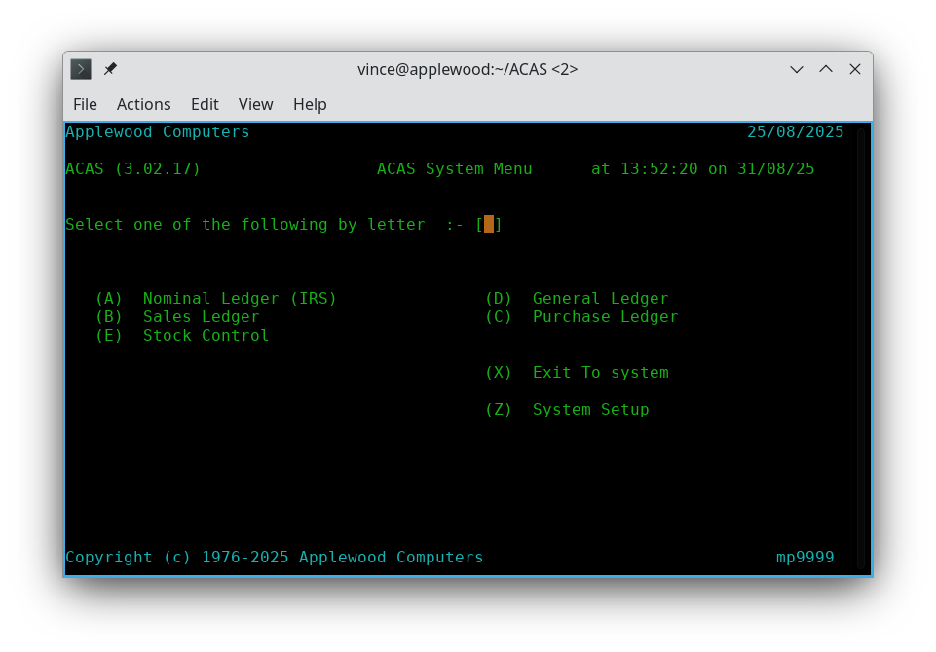

Figure 1.1 - The ACAS menu

PL System Facilities

The PL (Purchase Ledger) system is designed for use by business management and accountants who need to maintain control over their outstanding purchase orders / invoices. The package is very generalised so that it can be adapted to a wide range of business applications. The system utilises an open item invoice / Purchase Order system in that all unpaid invoices or purchase orders remain in the system for reporting or to display upon until paid in full or otherwise cleared by the business.

The following section describes briefly the advanced facilities obtained from the menu as shown in figure 1.2, which are available with the PL system. Notice that the top of the menu shows both your company name and the date and at the bottom the ACAS developer company as Applewood Computers, and the serial number for the ACAS software, which for the open source version is always mp9999.

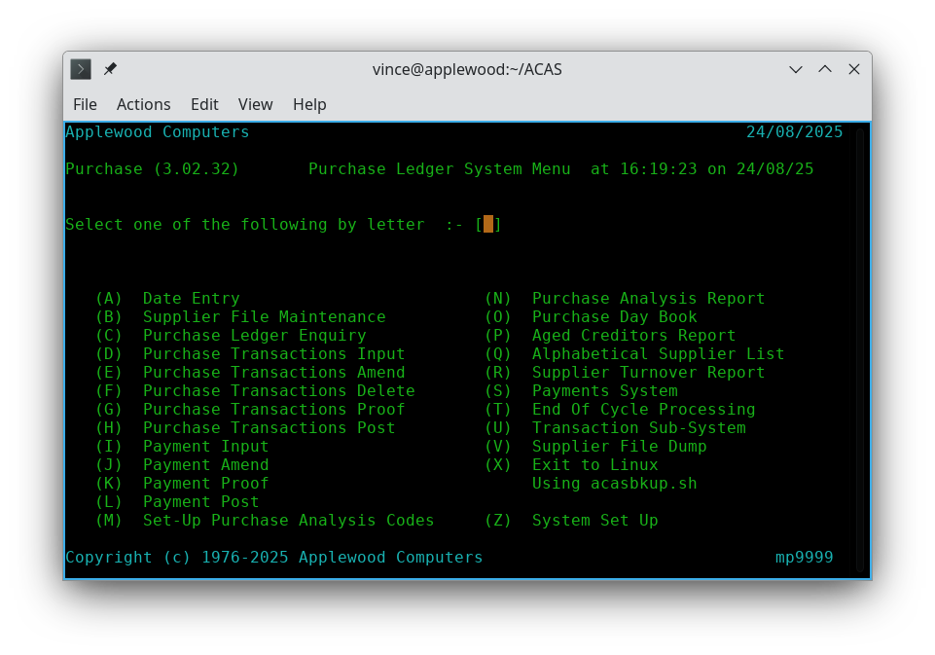
Figure 1.2 - Purchase System Menu

Now for a brief introduction to some of the features of purchase ledger:

Date Entry - Option A

Allows you to override today's date with another - not usually needed apart from may be testing.

Supplier File Maintenance - Option B
Via a sub menu allow selection to Enter, Amend, Delete, Display and produce a report of suppliers.

Purchase Ledger Enquiry - Option C

Similar in many ways to previous option but only for a specific supplier but will also provide the status of the supplier including how much is currently owed, how long and other specific data including a list of outstanding purchases.

Information on the purchase or debtor status of any supplier can be retrieved instantly by the on-line enquiry program. All information, including non-applied cash and non-billed (not yet posted) purchase orders are displayed plus the running totals for current and 30, 60 and 90+ days outstanding.

Purchase Transaction Input, Amend, Delete - Options D, E & F

Allows you to enter a new purchase order or amend or delete it.

Purchase Transactions Proof - Option G

Produce a proof report for all PO transactions not yet posted to the Open Item File. Use this option to verify transactions prior to running Post transactions.

Purchase Transactions Post - Option H

Post all current PO transactions.

[Manual] Payment Input, Amend, Proof and Post - Option I, J, K & L

Four separate options for manual payments namely Entry, Amend, Proof and Post.
You use amend to delete a payment Prior to posting it. After posting it cannot be deleted only credited off using a credit note transaction.

Set-Up Purchase Analysis Codes - Option M
Allows you to set up the default and other analysis codes and this also applies to the Sales Ledger system. This process must be run at the start of using PL or SL. Both will set up the same default codes but they will only let you set up codes for that specific system, i.e., sales or purchase. The analysis codes also require a IRS (or GL) account number.

Next, some reporting options :

Purchase Analysis Reporting - Option N
For accurate reports must be run after posting of orders and payments.

Purchase Day Book - Option O
For accurate reports must be run after posting of orders and payments.

Aged Creditors Report - Option P
For accurate reports, this must be run after posting of orders and payments.
The Aged Creditors Report will provide a wide range of system details, summary and exception reports which you can select from various criteria.

Alphabetical Suppliers List - Option Q
Produces a detailed list of suppliers in alphabetic order of business name as against by account number. It does assume that the name entered is in fact the business name as against a contact name which in that case will be the contact. Here is is clear that a decision must be made by the company as to what order the supplier name and address information is entered such as business name and in address first entry is contact say in braces/brackets () etc. followed by the address itself.

Supplier Turnover Report - Option R
Provides by quarter, last, average and last payment etc. For accurate reports, must be run after posting of invoices and payments.

Payments System - Option S
Generates pre process payments, and amend, proof, prints payment register and remittance advice notes if needed.

End of Cycle Processing - Option T
Before running this process check that all transaction orders and payments have been posted for both purchase and sales ledgers as well as all analysis reports produced. A data backup must be run prior to this step as well (a back up is always run when ever existing any of the sub systems.

Transaction Sub-System - Option U
Allows you to amend the fixed data, as well as selecting the recurring order processing.

Supplier File Dump - Option V
This report provides a lot more details where some might be of use in the event of issues with an supplier account. Some items on this report are controlled internally and cannot be changed by users. This was created mainly for testing but made available in case any users had a need It does produced a long report.

Exit to O/S - Option X
'O/S', - the system you are using such as Linux, Windows, OSX, etc., as defined in System Set Up.

System Set Up - Option Z
Set up the master parameter file records, usually just once or twice when setting up the system. This option can be used at any time and all setting will take immediate effect. This option must not be run when others are using the ACAS system as some changes may not be seen when running some of these options until exiting the sub system menu programs, i.e., irs, sales, purchase stock, etc..

Purchase Analysis & Purchase Statistics

For each supplier, current, previous and year to date transactions and payment figures is produced. All payment and transaction posting must have occurred prior to running this option.

IRS / General Ledger Interface

If the ACAS IRS (or GL) system is also used and this, is recommended, the system will feed summarised purchase and debtors information into the IRS system. The collection of data is automatic but the actual transfer between systems is handled by a special program option that for IRS, may be run at any desired interval, see IRS menu 4,66 (option 4 then 66). This must however, always be just before running any end of cycle processing having posted orders and payments. This is a semi automatic process. For GL these are generally posted direct to the posting file and no additional effort is required. The GL system is only for businesses needing profit centres and branch accounting although IRS can do the same by the use of sub nominal account numbers.

Line / Stock Item Accounting

The PL system does not use the stock control system as it has to cater for all types of purchases i.e., anything that the business may require to order whether it is pre-paid or on a credit account basis whether for resale or not. It is possible to make such a link to stock control if the bulk of orders reflect goods for resale using level 2 order entries. If this would be useful sent an email to the contact as shown on inside front cover of this manual.

Purchase Reporting

Using the default line item process, the information entered can be reported using the Purchase analysis feature. This report shows the accumulated purchase data on an analysis code basis for the current period, last period, and year-to-date. For audit purposes this is the recommended method and is in addition to all other processes including via IRS ledger reporting, Trail Balance and Profit and Loss reporting.

Adjustments / Credit Notes

Adjusting entries in the form of credit memo or notes can be made through purchase transaction entry.
Credit adjustments can be made for individual order transactions against individual suppliers. The supplier must be aware of this type of transaction and issued you with such a credit.

Autogen (Recurring purchase orders) - Optional and not yet available

When PO (purchase orders) are generated regularly for the same supplier and quantities, this subsystem can be used at any time to enter and modify the recurring PO. The system keeps track of when the autogen cycle is required and will produce a PO to be feed into the system prior to the final proof and subsequent posting of regular purchase orders.

Purchase Order Production

PO's can be created in a variety of differing ways to cater for the range of different businesses. These includes batched input, i,e., many PO transactions are normally added, prior to running a proof report before posting.

The source documents for this process can vary such as in
1. Received invoices for goods received regardless if it was prepaid or on account validated by received items at goods inwards.
2. Received packing / despatch note for items now received at goods inwards.
3. Copy of an actual PO sent to a supplier that provides amount values for goods ordered.
4. Copy of an email, Fax or other form of communication detailing a PO doing the same.

The term here, of a batch, is where a number of transactions are entered into P/L at the same or similar time period prior to posting.

Operating Summary
The 12 sections in this chapter correspond to the 12 major processing steps in the Purchase Ledger system (Figure 1.3). The text describes when each step can or must be run from the viewpoint of a computer operator or user, If the printer is required, and any other operational concerns are also discussed. The programs mentioned in this chapter are described in greater detail in the remaining chapters. This section is an operational guide only.

- System set up & Parameter data Entry
- Set-Up Purchase Analysis Codes
- Purchase Order set up
- Stock Control Set up and data Entry
- Supplier File Maintenance
- PO / Folio Transaction data Entry
- Payment data Entry
- Payment generation
- IRS data extract processing
- Producing Reports
- End of Cycle
- Auto Generate Purchase Orders
Figure 1.3: Primary Processing Steps

Some steps will only be run once or twice, such as the Set up's e.g., System, Purchase Order / Invoicing or Analysis Codes. Other steps are run on an irregular basis with no relationship to the invoicing / purchase orders and payment creation cycle timing, such as Supplier File Maintenance. Others are run very regularly, yet not necessarily on a one to one relationship with the payment or purchase order cycle such as the transaction or payment input steps.

Even programs in the individual steps need not be run at the same time. For example, you would most likely run the transaction entry programs more often than the payment proof and posting programs, yet all of these programs are considered part of the transaction or order entry step.

Steps 1, 2, 3
Preliminary steps that are run infrequently normally on the initial set up of the system where steps 1 is the same for all of the ACAS sub-systems and step 2 for both Sales & Purchase Ledgers which is also tied to IRS (or General Ledger) as the accounts need to be set up in order to provide account numbers to link to each analysis code and step 3 - Purchase Order set up.

Step 4
Creating and maintaining the Stock control system records for products or services sold or charged for, including to record new stock arriving but also see Sales Ledger. and Stock Control manuals. This is currently not used in PL but it is in SL.

Step 5
To create the data for each supplier when required or to modify information on existing suppliers such as address changes, email addresses, phone numbers, your credit limit (where known), etc.

Steps 6 and 7
Main financial transaction steps in the system and are used most often. These steps may be run often, depending on the volume of transactions. There is no sequential relationship between PO entry and payments entry other than to ensure that all transactions are entered prior to doing the payment cycle otherwise you could easily miss some required payments against your purchases as they are not searched against during payment entry processing.
Payment programs may be run as many times as necessary without regard for the number of times the PO entry programs has been run however it is usually run once per cycle such as monthly or even weekly if there is a need but paying monthly does provide better control over your cash flow.. Most of the data entry work is in these two steps. For monthly type payment processing use the payment processing option S as against options I - L which is for manually entering payments out of the monthly type cycle which can be run using other periods such as two weekly, weekly, etc. Also see step 8.

Step 8
Payment processing, is the one step required by the system to be run on some fairly fixed schedule. The payment generation programs must be run at least one time per cycle, but it does depend on how often you are doing bank and mail / email receipt reconciliation's to check on funds at bank so you can make payments, etc.

Step 9
Run after the processing transactions and payment postings along with payments generation for which irs is run to import the file created by both purchase and sales ledger processing to add the posting data. This step can be run as frequently as daily but after all processing by sales and purchase ledgers have been completed by all users such as at end of day.

Step 10
Reports may or may not be generated on a specific schedule, however the IRS (or GL) data extract (step 9), must be run after posting the final transactions and payments, so that reporting is valid as at say, the end of each period. i.e., daily, weekly or monthly, etc.

Step 11
This is the end of cycle processing run as the last process at the end of period such as quarterly or yearly. This process processes all sales and purchase data and must only be run after all other end of period processing has been completed and after a back up of the data is run such as produced when exiting from purchase / sales ledgers, irs and stock control.
This processes updates cumulative totals for monthly, quarterly and yearly values then clears down for the new current periods.

Step 12
Recurring purchase orders creation, as needed if being used. Most businesses would not normally use this. This is not coded at this time as it is expected that very few if any businesses would require it. It is available in Sales Ledger.

Operating Detail

Step 1: System Setup & Parameter Entry - option Z

System set up must be performed at least once before any other programs in the ACAS system are run and for this to happen whenever you run ACAS, irs, sales, purchase, stock and general for the first time this process will be automatically run if no system files exist. If you need to rerun this, it is always option 'Z' from any of the main menu's in ACAS, sales, purchase, IRS, Stock and General. System Set up may be run any number of times after its initial execution if you need to change any of the system parameters.

A printed report on the current system parameters is available from this program. The report serves as a backup and should also be considered part of the audit trail. This process does not report on all items, only the primary ones as the report would be a long one.

Step 2: Set-Up Purchase Analysis Codes - option M

This step is normally done once for the default codes and after having set up IRS (or G/L) accounts that will retain the totals from the analysis codes. On first entry, it will create the predefined codes for Vat / Purchase tax etc., for both Purchase and Sales and some other defaults for purchase ledger. Any others that are required, can be added and at any time providing you have set up the associated accounts in the IRS General / Nominal ledger. This function is available for Sales as well as Purchase and will be run if the file does not exists.

Step 3: Invoicing Sub-System - option U

Amend fixed data and this has two data fields and a confirmation box :
Next Folio : This function is usually only needed to be done once and you can set up the Next Folio number to be used, this is used as the purchase transaction order number. You can change this at end of year if you are using the 1 or 2 leading digits to indicate the year or other similar function.

Vat Account : Allows to define the account number. which when you move from Next Folio, it will be pre-filled in with the default account as set up via the parameter file settings.
If you need to change it, enter the account here with the last option as; OK to file (Y/N), Press return to accept Y or enter N to redo the two data fields. It does not verify that the account number exists so make sure it is does otherwise statistics will be wrong, how ever IRS should issue an error message if this occurs.

Note that IRS uses a five digit number but General will use six where you would normally keep the first digit of the number set as zero so that the same account number can be used for both systems.

Step 4: Stock Control Set up

Enter your Sales products as stock items with retail, cost pricing, produce source (suppler etc.), stock location (for the packing team) and other sundry items. You will need a stock list to be taken at a quiet time such as a weekend or bank holiday so that the current stock position is fully recorded for all items sold. Here, you can add service items as well, such as post and packing charges by courier, weight, speed and insurance etc. You will need to review these charges when ever the couriers or postal services increase their charges to you.

Step 5: Supplier Entry

Supplier entry must be performed at least once before any higher numbered steps. It may be run any number of times at any point after step 1, 2, and 3.

The supplier entry step consists of a data entry step, an optional printing step that may precede the others. This prints the suppliers in supplier number order, however other options are also available. Note you can enter this function when in Transaction Entry when the system is asking for a supplier account number by pressing the F1 function key (or entering NEW as the number) and after processing a new supplier, it will return to the same point in the transaction entry process.

Step 6: Transactions Entry

This step may take place any time after steps 1, 2, 3, 4 & 5.
The Transactions Entry step consists of five programs: Entry, Amend, Delete and Proof and can be run as many times as desired independently of each other. Running post is the final function after completing a last proof step.
A function (via the F1 key, or entering NEW) exists that allows you to create a new supplier should the need arise during transaction entry instead of using step 5. The notes for Step 7 also apply and also see Step 5.

Step 7: Payment Entry

Manual Entry

This set of processes is for payments that have to be made outside the settings for supplier credit period in days where such payments are required ahead of such terms of trading.

The payment entry step may be run any time after steps 1, 2, 3, 4, 5 and 6. You cannot process payments if transactions do not exist and have been not been proofed and posted. It follows that the transactions post must have been run prior to this payment entry.

This step consists of four programs: entry, amend, proof, and finally posting. The entry, amend and proof programs may be run as many times as desired independently of each other. These programs can build, modify, and report on a batch of payment transactions until that batch is posted.

You may proof a batch any time during its development and a proof report must be processed before posting. A proof is part of the audit trail assuming it is taken immediately before posting (i.e., no intervening executions of a Payment Entry). If run before an execution of Payment Entry or Amend, the proof is considered a work sheet only. The final audit proof must be taken just before posting. Such reports should be considered as part of the audit trail for your book keeper, accountant and tax authority.

Once the current batch is complete and accurate and has been proofed for the final audit report the batch can be posted to the open item file. You can only input a payment to a posted transaction that is now on the open Item file so where a payment is sent with the order etc., you must only issue a receipt instead of an invoice type transaction.

Automatic Entry

Slightly similar to manual entry but relies on the supplier settings of credit period to generate payments due. Options are generate due payments, amend, proof, generate actual payments, print payment register (this updates the Open Item File with the payments) and lastly print remittance advices. Allowances are made for the use of B2B (Bank to Bank) payments instead of cheques.

Step 8 Payment Generation

Can be used in addition to manual payment entry.
Allows you to automate payments according to individual credit terms on a per supplier basis, e.g., generate payments for all outstanding at say 28 days or more likely 30 days (monthly).
You can amend such lists produced to remove or add one's you do not wish to pay and produce a report of such suggested payments prior to continuing with the other processes in this step.

Step 9 IRS / General Ledger Extracting

The IRS (and GL) extracting step is a non selectable process. It applies for both IRS and GL It is done automatically during steps 6 and 7 within the posting processes for both invoices and payments. These steps are taken only if the IRS (or GL) interface is requested during Step 1 System Set up.

IRS has a step that accepts these postings into the system via menu option 4 - Posting, sub option 66 - Add SL or PL Postings from file.
For GL, data is sent direct to the posting file and this again, also applies to Purchase Ledger.

Step 10: Producing Reports

Any of the report programs can be run at any time after step 1, but the results will not be meaningful until the appropriate steps have been completed and normally step 7 has also been run, and the various Purchase reports after steps 7 etc.).

The Purchase Day Book and the Aged Debtors Analysis report should be considered part of the audit trail as well as for the users in the Purchase team who require them on a day to day basis. The same applies for the Purchase Ledger reports and as needed for Stock Control.

Step 11: End of Cycle

This step is normally run at the end of the last business day of the month and processes statistical data for the monthly cycle and passes data to the IRS (or G/L) systems. It precedes this with a Analysis and Day Book report for S/L and similar for P/L and the other sub-systems then updates all system files for end of month. Note: This is done for all of the sub systems, sales and, purchase, at the same time, but the user can specify. Prior to running this step is is recommended to always carry out a back up of all of ACAS data files as there is no recovery from this action other than restoring the files, you are warned of this prior to running. The same applies, if you are running a rdbms system in place of the standard Cobol data files but note that if you are, the system (parameter) file is always maintained in the ACAS data directory. The system, unless changed when installed, will make a back up of the standard Cobol data files after the user selects 'X' for exiting the system and as supplied it does not do so for rdbms as there is multiple ways of doing so, at controlled intervals. For IRS and General (if used over IRS), these have their own end of cycle processing so read the relevant manual for more information although in most forms this is only required at the end of year.
Stock does not require any end of cycle process other than a check on stock items held in stores, etc. against counts produced on the stock reports. This process can only be done when there is no processing being undertaken such as during a weekend or a bank holiday where there is no processing for new purchase orders or sales. Any discrepancies must be investigated as it could be misplaced stock (stored some where else in error or stolen or goods inwards figures were wrong or any other possible reasons.

In the event that this process is run after the last day of the month e.g., a few days into the new month because of holidays or weekend, then the date set function which is menu option '1' should be set to reflect the last day of the preceding month before running End of Cycle if only for the date that is printed on the reports.

There is also a end of year cycle that runs for all subsystems that are used within ACAS, again IRS or GL differ as at least for IRS can be run into the new year, see their manual for more details.

Step 12: Auto Generate Invoices

The Autogenerate Transaction Orders step is optional. It is sometimes used in place of, but usually in addition to the invoice entry programs. It is not present in PL.

An example for this is to create periodic transactions/invoices such as monthly, quarterly and yearly for maintenance contracts for software support or charges for rent, rates or hire charges. It is not usually used in PL and therefore has not been coded but it can be if users request it but so far no one has.
It is normal to create in stock control as service items for usage here, where such items defined as a service only record Purchase and therefore has no effect on actual stock. You could of course use actual stock products if it is required, although more unlikely. No doubt some one can provide an instance of this.

The Proof Autogen file program may be run at any time to print a proof sheet. This report is not part of the audit trail but you should retain the latest copy if only you need to amend existing records, or know what is in the system at any point in time. You can create these entries to be for ever, or have a limited number of uses per supplier by using the repeat field.

The Autogen posting program must be run before the end of a transaction cycle but can be for invoices issued monthly, quarterly or yearly. This step actual posts these records to the invoice file and therefore the transaction post program must be run after but so in any event, Autogen posting will be run, prior to the processes that runs the invoice posting program, see step 6.

Using the Entry programs

There are three types of processes or programs in the P/L system: Entry, Processing, and Print programs. The print programs produce reports or lists and are described in various chapters. Each processing program is treated in a separate chapter. This chapter discusses the features common to all but the Transaction Entry, Payment Entry, Payment generation and the optional Build Autogen / Recurring transaction File programs.

Using the Print programs

Most ACAS print programs including P/L, produce 132 column reports and therefore the printed text size is adjusted to fit on the page in landscape mode. In some cases the report is printed in Portrait style for narrow reporting such as using 80 columns and in the others in Landscape. It is up to the spooler settings to ensure that for printers that can run in duplex mode, that the printer is correctly set for long edge (although you might want to use short edge) Landscape and possibly in Portrait modes and this is set up in an included routine as required by each program. The programs themselves, help to ensure this is true, by forcing the correct modes when issuing the 'spool to print' command that in turn is a hook to the Cups printer system that is installed as part of the operating system, at least for *nix systems such as Linux. It does depend of being able to override the default printer setting in Cups if needed. For other systems such as windows it depends on the installation and use of printer drivers such as from HP, Epson, etc., being correctly set up. Some of the print programs only use 80 to 96 columns but the majority do use 132 columns so use landscape mode.

Almost all print programs are "read-only". Because they never write data to the files, a printer malfunction will never damage valuable master files.

There are exceptions, the reports produced by some of the 'End of Cycle' steps, the reports which were not printed before running, as this is not re-runnable without restoring the data from a back up. In the generate payments step, one process does update files and you are warned of this before running.
There are many checks to try and ensure that all needed reports are done in order, but it cannot be guaranteed.

In this regard it is important to exit the system so that a back up occurs, checking that no errors occurred during the backup, before rerunning P/L and then selecting for example, the 'End of Cycle' processing step. During this process you are offered the options of running End of Cycle for Purchase and for Sales ledgers.

For IRS, the end of cycle process is done via the IRS menu, likewise GL. For stock control, this usually consists of producing the current state of stock both by numbers of items per product and valuations for both cost and retail as well as lists of items that have fallen below the re-order point and this is done within the stock control system.

You must always have a run a back up step or just prior, exiting the system so that one is created before running any end of cycle processing.

This, is the default procedure.

System Set Up

The System and Parameter Files Set up - Option Z
This option can be selected via option Z (using program sys002), regardless of the system or sub system that has been started so running ACAS or one of the sub systems such as Stock, Purchase, etc., will result in the ACAS parameter file set up process to start if this is the first time of ACAS usage, and this is the same as selecting Z when running the ACAS process. This chapter is also in Building the ACAS System manual and may well be more up to date and go in to more detail than here. This file, is always created even if using the database system for storing all ACAS data as it is needed to obtain the required settings to access it. The information in this file is also transferred to the system table in the database at the same time so both are kept up to date.

System parameters are items of information that are used by programs from the ACAS (Applewood Computers Accounting System) Sales, Purchase, IRS, General, Stock systems to control the various processing functions. This applies to each of the ACAS sub systems. The set of parameters used by the system defines the kind of Ledger application being maintained and the way it will run. The data entered can and in many case will effect the way the whole ACAS system operates and can be entered and changed by any of the ACAS sub systems and more or less at any time however, when turning on RDBMS file processing after using the normal Cobol file processing, care must be taken before turning off the Cobol file processing to ensure all data has been transferred to the database by running the ACAS database load programs. See Building the ACAS system manual for detailed information. It is not recommended to run this step if other users are using the ACAS system as some parameters may not be seen other than the start of processes / programs.

One file contains the ACAS system parameters (system.dat). This is built and modified by the Parameter Set-up program. Many but not all parameters have a default value (the value assumed if no value is explicitly stated by the user). As new versions of ACAS are created new parameters may well appear along with default settings and are shown on the existing screens where ever possible. It is possible that the manuals may not reflect 'the' latest version of any sub system but it is hoped that a manual is always updated to reflect the new changes and additions to the accounting software. Note that while the various systems within ACAS run, some of the parameters are updated.

Modifying the default parameters takes place through entry screens. At first time start-up however, you should not change the defaults of the Payments, sales, purchase and Stock account numbers until you have run Chart of Accounts Entry in IRS (or General Ledger), if you wish to use one of them to process your Nominal records, and created the accounts to which you want to change them to. In this regard setting up IRS (or G/L) should be done first before entering the account numbers. However there is no reason why you cannot update these after you have set up IRS or G/L and it may be logical to do so. For IRS there is a standard Chart of Account file that you can use to create your CoA (Chart of Accounts), so see the IRS manual for details. It is recommended that this process is done at the prior to running ACAS parameter set up. This COA file should be copied to another file with a different
name such as your business name and '-coa-1.txt' such as dykegrove-coa-1.txt. Where '1' is the version of the file as you make changes and save the contents. This way you can revert back to a prior version with minimum effort.

Reading the IRS manual, then make any changes you need by replacing the text used for descriptions where they differ from one's used within your business such as names of directors or other senior managers for petty cash accounts etc. Once done you import this new file into IRS using the special import process. See the IRS manual for more information.

The Set up Parameter Entry program behaves the same as the data entry programs, except that the program is always in "changing" mode. The current value of each parameter appears on the screen and new input requested. If you hit the RETURN or TAB key, the existing (or default) value remains. When a valid parameter value is entered, it becomes the new parameter value when exiting that sub systems settings.

Certain parameters cannot be changed once transactions have been made in the system. The set up parameter program will not issue requests for these "protected" parameters.
Most parameters may be changed at any time, but the range of changes is restricted. For example, the maximum number of billing cycles may not be lowered unless unused cycles are being eliminated.

At the end of the entry session, the program asks whether to print a hard copy record of the parameters. If the reply is Y (yes), the report will be sent to your printer via the printer spooler as are all reports. For *nix such as Linux use the Cups package to create the spools for your printers before running ACAS as it will make it easier to print out.

Note that the graphics shown in this chapter may not be for the latest build of the parameter maintenance program.

The questions in the very first screen 0, will only be requested once at the start of creating the parameter file for the first time so make sure you have entered the Company name correctly and also the sub systems that will be used. If you 'might' use any sub system set it to 'Y' to be sure the relevant parameters are pre set up. This is a security feature for the commercial versions of ACAS but for most of the sub systems, they will turn on this setting but not set the parameters they might require. Worse comes to worse then you can just delete the system.dat file and let the set up process recreate it.

For a new system the first screen will request the name of the company or business that will be used in the title of all system screens as well as for all reports, statements, invoices etc.

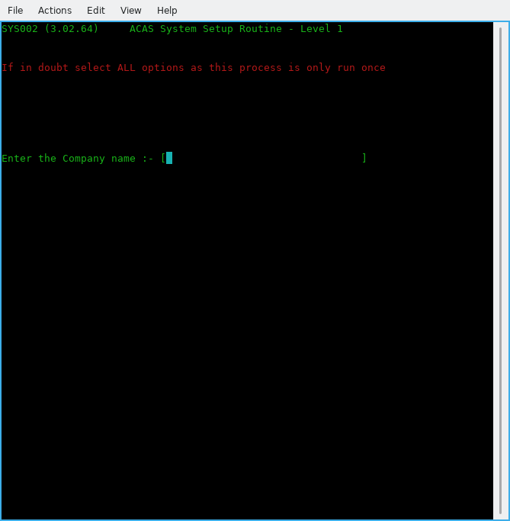

Figure 6.1 - Business name entry

(0-01) Enter the Company Name

This is the name of the company for whom ACAS will process. If ACAS will be used on several client companies, this name clearly separates the data of different companies. Maximum length is 32 characters. After typing the name and hitting enter you will be asked to verify it is correct by entering Y or y. If not, enter N or n and you can re-enter the information.

Note that if you will be using the IRS system you will be asked for the name of the IRS client (which is the business that requires the accounting processes) which will more than likely be the same name but might not depending on group requirements.

The IRS client name can always be changed should the need arise.

The next series of questions requests what ACAS functions will be used, see figure 6.2.

(0-02) Using subsystem xxxxxx

Here enter a Y or N against each entry in turn depending on your requirements. If in any doubt, turn them all on unless you know that you will not be using them e.g., Stock Control if you are a services only company and do not hold stock but remember you can set up services into stock control such as P&P, rental, hires etc., etc.. Having responded to all questions you will be asked to confirm selection and at the same time a display below the question will show what has been selected. If you are happy, enter Y and return else enter N and you can re-enter the answers.

[ You can not re-do this group of questions, so always specify all sub systems and make sure that the business name is also correct before moving on. ]

The parameter requests and their defaults are shown and described individually in the remainder of this chapter. The number in parentheses is not displayed by the system but is printed in the manual for reference.

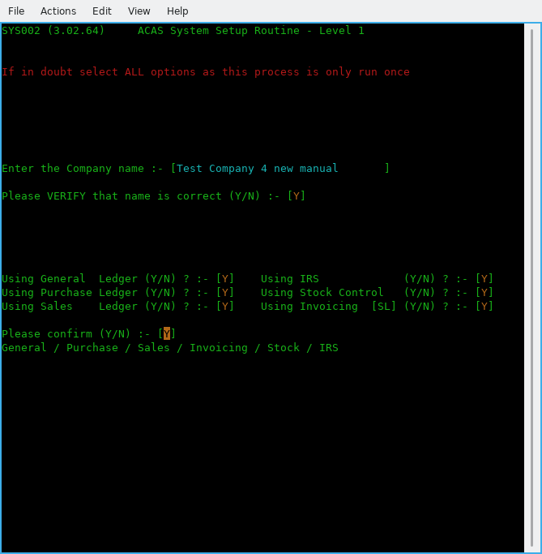

Figure 6.2 - The various ACAS systems to be used

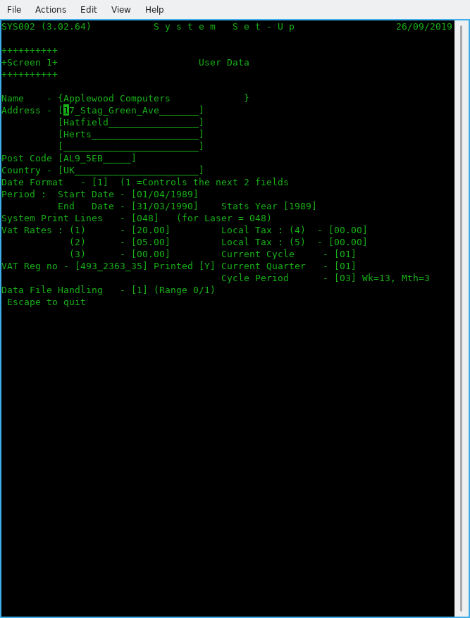

Figure 6.3 Screen 1 – User Data

(1-01) Company Address – 4 lines

Enter up to 4 lines of address (24 Characters each) excluding Postcode and country, that's next.

(1-02) Company Postcode or zipcode (12 characters) then Country (24 Characters) followed by the company email address.

Enter the postcode then the Country or state if required.

(1-03) Date format.

Select the format used in your country.
Select 1 for the UK (dd/mm/ccyy),
2 for the USA (mm/dd/ccyy)
3 for international (ccyy/mm/dd)

(1-04) Start Date
(1-05) End Date

Enter the start and end dates for the current financial year in the format selected above in (1-03) you can use '/', ',' or '.' to separate the day, month & year as it will be converted to '/' as needed.
For example in the UK they would be:
01/04/2024 and 31/03/2025

(1-06 Stats Year

This is the year used for all Statistic reporting. Normally set to the same year in End-Date, but can be changed if different.

(1-07) System Print Lines.

For a laser and Ink-jet set to 048 as a good starter and adjust if your reports are printing, too long or too short. For a matrix or line printer use 66. This is NOT for SL Invoice or Packing note printing but for all other normal system reporting.

(1-08) Vat Rates (1), (2) and (3)

Enter the current Vat / tax rates with the more commonly used at the beginning. Using TAB to go to next field. This normally would be: rate 1 – Standard, rate 2 – Reduced and rate 3 – any other, such as zero. Use these three in that order and purpose.

(1-09) Local Tax (4) and (5)

If needed set these similar to Vat Rates. (For the UK leave as zero). The O/S (open source) versions do not currently use these two rates but if needed, issue a Feature Request.

(1-10) Current Cycle

Enter the cycle to be used, e.g., in the UK and at the start of the financial year using for month 1, week 1 enter 01.

(1-11) VAT Reg no

Enter your VAT or DST registration number then select Y if it is to be printed otherwise N.

(1-12) Current Quarter

Likewise in previous entry (1-10) e..g., in the UK at the start of the financial year enter 01.

(1-13) Cycle Period

Enter the relevant period e..g., 03 for Monthly, 06 fortnightly and 13 for weekly. The normal value here is 03 for monthly.

(1-14) Data File Handling

Set this to zero for normal Cobol files and for RDBMS (Database) processing set to :
1 for MySQL,

[ The following are not yet implemented and will be subject to user requests. ]
2 for Postgres,
3 for Oracle,
4 for DB/2 and
5 for MSSQL Server,
6 for ODBC.

See later for setting the RDBMS entries in (3.01) onwards.

Pressing enter now will bring up a confirm message and the screen has changed to reflect your entered data. If you need to change any of the settings, e..g., Date format, Cycle period, Cobol data files used, etc., select N and re-do any that are in error.

If all is correct enter Y to go to screen 2.

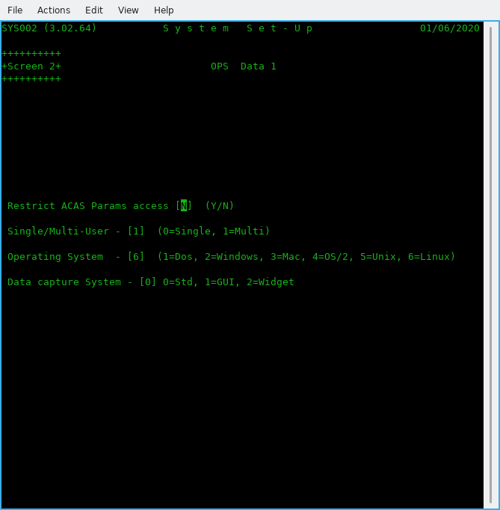

Figure 6.4 Screen 2 – OPS Data 1

(2.01) Restrict ACAS Param access [N]

Enter N (for No) or Y (for Yes). Normally leave as N unless you wish extra security to prevent users changing this option. It can be set as NOT allowing users accessing program sys002 by changing Group and other privileges via Linux / *nix and possibly in Windows, subject to what version you are running and this is the normal method you should use but is here for future development, may be.

(2-02) Single/Multi-User – [0]

Enter 0 = for Single or 1 for Multi-user systems. If more than one user will be using the ACAS system possibly at the same time select 1. Normally enter 1.

(2-03) Operating System - [0]

Enter the correct value for the OS (operating system), Make sure you select the correct value as ACAS will function differently depending on system in use. Most common is Linux or Windows. If in doubt ask your IT department. If using Linux under Windows & WSL select Linux.

(2-04) Data capture System - [0]

Enter zero for now but options are 0=Std, 1=GUI, 2=Widget. This entry is for future expansion. After pressing the Return key, the system will ask to confirm your answers.

(2.05) A new box appears for all, other than Dos, requesting the print spool names as set up e.g., in Cups when using Linux, Unix or OSX.

Type the name in exactly, as set up in Cups, be careful regarding case e..g., upper and/or lower case – they are treated differently.

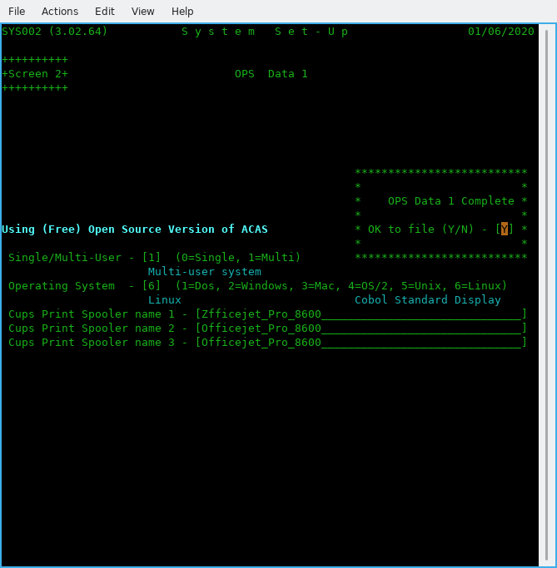

Figure 6.5 Screen 2– OPS Data 1 after data entry

If this is wrong you will not get any reports. A good test that this is correct is after you say Y to the print a hard copy of the parameters question at the end it will produce a report. The typical error produced for this is: 'lpr: The printer or class does not exist' as shown at the command prompt having exited from ACAS.

If you selected RDBMS processing then screen 3 will now appear.

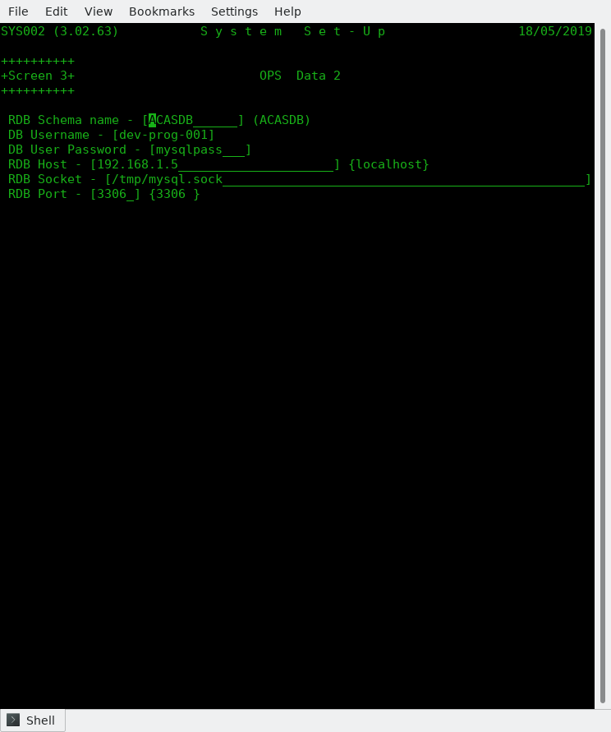

Figure 6.6 Screen 3 -- OPS RDBMS Data

Here you enter the various parameters for access to the data base.

(3.01) RDB Schema name -- Defaults to ACASDB.
(3.02) DB Username -- Give the user name as set up in the data base.
(3.03) DB User Password -- Likewise their password.
(3.04) RDB Host -- The IP address of the system running RDBMS. Default
localhost (the same computer you are running ACAS on.
(3.05) RDB Socket -- As set up in MySQL configuration file normally - my.cnf.
(3.06) RDB Port -- As above and defaults to the normal value of 3306.

You are asked to confirm your entries and giving N will restart again on OPS data.

Note that you must have the RDBMS system installed, running and configured with the ACAS data base tables set up - see Building the ACAS System.

Failure to do this and answering Y to update the parameter file with your data will result in errors when the ACAS system attempts to update the data base table SYSTEM-REC having already updated the parameter file which is always created.

Should you not be in a position to have the RDBMS running with the ACAS database loaded you should change the setting for (1.13 to 0 (zero) to keep file processing active at least for the moment. You can, having got the Database loaded etc., go back into parameter set up via menu option Z and set (1.13) to 1.

If having entered the RDBMS data and set Y(es) to save the parameter data and gotten error messages saying ACAS cannot access the database, when the system returns back to the beginning of parameter data entry, you can do the same and set (1:13) to 0 and the RDB information will be saved but the system will use Cobol data files for all processing -- very useful during system testing, etc., but note that the parameter report will not show RDB data is set to file processing.

Screen 4 is now displayed and that covers G/L Data.

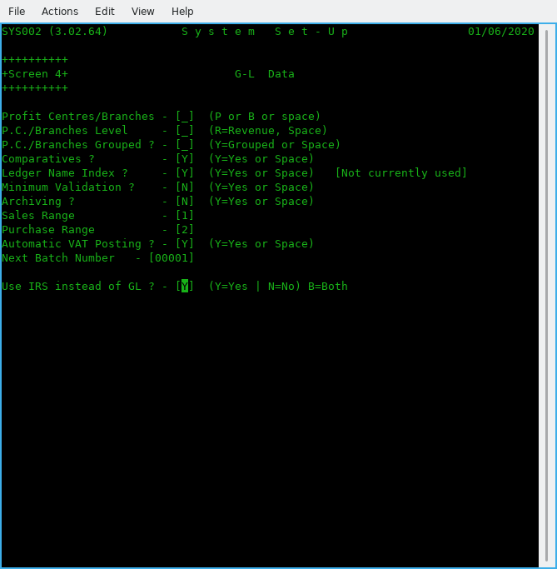

Figure 6.7 Screen 4 – G/L Data

This screen is only if you are going to use G/L instead of IRS in which case read the G/L manual for more information about the values but for the moment enter as per figure 6.7, i.e., enter a space for the three questions on P.C. (Profit centres) and 'Y' for comparatives and Ledger name index. Then enter space for the next 2 question on Minimum Validation and Archiving. Change as ** zero respectively for the next 2 questions on Sales and Purchase ledger ranges (which are pre-set to 1 and 2) followed by 'Y' for auto VAT posting. Use 00001 for Next Batch number, and finally Y if using IRS instead of G/L. **Note that if you need to set up the Sales and Purchase account entries in G/L you must leave these values initially as zero in order to create these accounts, otherwise the system will refuse to allow accounts starting with 1nnn and 2nnn to be created.
If you are going to use both IRS and G/L, set this value to B for Both.

After these have been set up you can change these two values to the correct leading numbers respectively however they do not seem to be currently used – Subject to system testing but for all system testing, we currently only use IRS as that is used for company accounts and for our clients.

Now pressing enter, will again let you confirm the answers with the display changing to show what has been set. Use N if you spot any errors and re-enter the correct answers and enter to go to the next screen. Use TAB or the arrow keys to move between entry boxes, this applies to most screens.

Now we finally get to parameters that relate to Sales Ledger on Screen 5

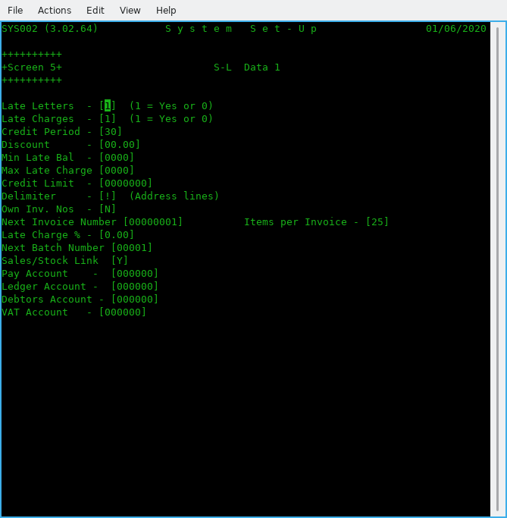

Figure 6.8 Screen 5 -- S/L Data 1

(5-01) Late Letters [1]

This request determines whether Late payment reminders (dunning) letters are used.
If yes set to 1, the late letter program may be used to write reminder letters to overdue suppliers otherwise enter 0.

(5-02) Late Charges

This request determines whether or not late charges are used throughout the system. If yes (1), the payments apply program will generate charges on overdue balances otherwise enter 0.

(5-03) Credit Period

This is the normal number of days to give for credit. You have the option of changing this for individual customers.

(5-04) Discount

Default discount offered to customers and again can be change for individual accounts.

(5-05) Min Late Bal

The Minimum Late Balance is the value below which late charges will not be applied.

(5-06) Max Late Charge

The highest amount that will be charged for late payments.

(5-07 Credit Limit

During Customer Entry this is the amount that will be placed in each customer's record to show their credit limit, in the absence of other instructions and you can over ride this value. It must be an integer from zero to 9999999. Balances over the credit limit are acceptable, but these clients will be flagged on reports and on Invoice entry. Do not use large values.

(5-08) Delimiter

This is the character that delimits address lines. It is recommended to be set as '!'. unless you get the same character within addresses in which case select another that is not used and one to consider is ‘|’. Despite what was acceptable for earlier version of ACAS you cannot use the slash symbols e.g., ‘\’ or ‘/’ as these will interfere with running using rdbms and are now not allowed. This should be the same as P/L (Purchase Ledger).

(5-09) Own Inv. Nos

Will the users be entering your own invoice numbers?
Set to N if you want the system to handle it. If so, the system will also reallocate deleted invoice numbers so you do not end up with missing numbers for audit purposes.

(5-10) Next Invoice Number

Leave this set to 1 for new system set ups -- this will be incremented by 1 for every invoice created in the system so if it is a higher number normally you should leave it as is.

(5-11) Items per Invoice

Defaults to 25 but change it for the number of item lines to be printed in one invoice page. The system will create more invoices if this is exceeded as Page n of y. etc.

(5-12) Late Charge %

This is the percentage of the outstanding amount that will be used as the late charge.
This number may contain 1 digit to the left and up to 2 digits to the right of the decimal. For example, the default of 1.50 is one and one half percent of the overdue balance. Lowest values are 0.00 and highest 9.99. This charge applies per cycle e..g., monthly.

(5-13) Next Batch Number
Normally set this to 1 if S/L not yet processed any invoices otherwise shows current next batch number that will be used.

(5-14) Sales/Stock Link

Set to Y if using Stock Control and you want it linked for invoice production. Else set to N.

(5-15) Pay Account

This is the number of the account to which all payments/cash receipt transactions will be debited.

(5-16) Ledger Account

This is the number of the account to which all Sales transactions will be credited.

(5-17) Debtors Account

This is the number of the account to which all Sales transactions will be debited and all cash receipts transactions credited

Note: Assuming IRS or G/L has been set up with a CoA (Chart of Accounts) you can enter the relevant accounts. If not set up or you will not be using either system then leave as zero. Not setting IRS up, will result in additional work load as you will have to enter such data manually on a possible daily basis. If using both IRS and GL use five digit numbers only.

(5.18) VAT Account

Enter the account that you have or will set up to hold VAT for Sales inputs.
If using IRS and the supplied accounts file coa-archived.txt, the number is 000277.
After pressing enter for this last parameter you will be asked to confirm the S/L settings with the screen being updated to show your settings. Entering Y will move on to the next S/L screen.

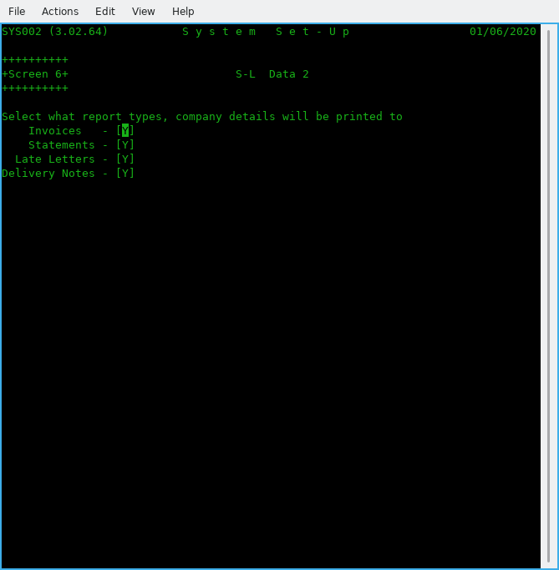

Figure 6.9 Screen 6 -- S/L Data 2

Company detail printing, only four entries here, all with a Y or N as valid data
Should the company name and address be printed for :
(6-01) Invoices
(6-02 Statements
(6-03) Late Letters
(6-04) Delivery notes
Enter Y for Yes otherwise N for No. If you are using plain paper or Email for any of these reports, the normal setting is Y. If not you need to be using preprinted stationary such as for a Matrix or Line printer. Many modern up market Laser and Ink-jets can use a template that is preloaded prior to printing off these documents. Just remember to clear the template after printing unless you are reserving one printer to do each reporting type.

The next screen, 7 is for P/L - (Purchase Ledger) data

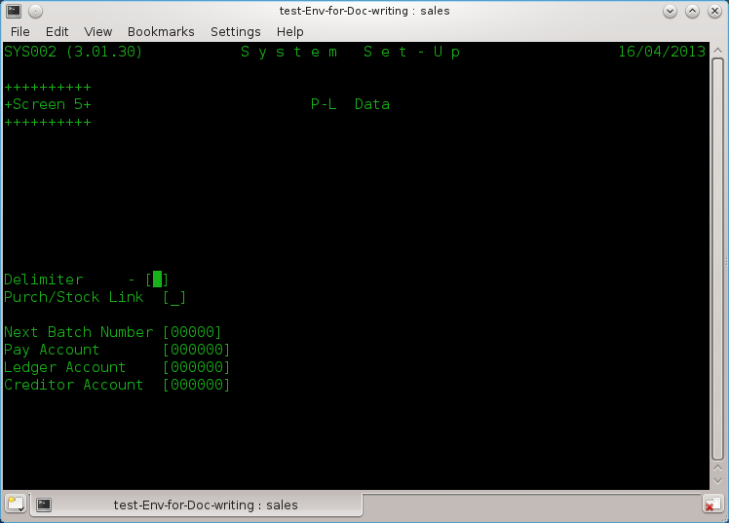

Figure 6.10 Screen 7 – P/L (Purchase Ledger) Data

Purchase Ledger parameter data is a small but similar element of the S/L data. So now you know what is what regarding S/L, P/L will be a 'piece of cake' as there is a lot less parameter fields to enter.

(7-01) Delimiter

This is the character that delimits address lines. It is recommended to be set as '!'. unless you get the same character within addresses in which case select another that is not used and one to consider is ‘|’. You should be using the same one for both Purchase and Purchase Ledgers to avoid confusion when entering data. Despite what was acceptable for earlier version of ACAS, you cannot use the slash symbols, e.g., ‘\’ or ‘/’ as these will interfere with running using RDBMS and are now, not allowed.

(7-02) Purch/Stock Link

Set to Y if using Stock Control and you want it linked for purchase orders. Else set to N. THis is ignored by PL as stock is not used.

(7.03) Next Folio Number

Normally set to 1 when entering data for the first time otherwise leave as is currently.

(7-04) Next Batch Number

Normally set this to 1 if P/L not yet used otherwise shows current next batch no.

(7-05) Pay Account

This is the number of the account to which all payment transactions will be debited.

(7-06) Ledger Account

This is the number of the account to which all purchase transactions will be credited.

(7-07) Creditor Account

This is the number of the account to which all purchase transactions will be debited and all cash receipts transactions credited.

Note: Assuming IRS or G/L has been set up with a CoA (Chart of Accounts) you can enter the relevant account numbers. If not set up, or you will not be using either system then leave as zero. Also see comments earlier regarding using both IRS and G-L.
Warning: The system will not check that these accounts have been set up, the same applies to S/L, so any postings could just disappear.

After pressing enter for this last parameter you will be asked to confirm the P/L settings with the screen being updated to show your settings. Entering Y will move on to the next screen.

We now move on to the secondary systems.

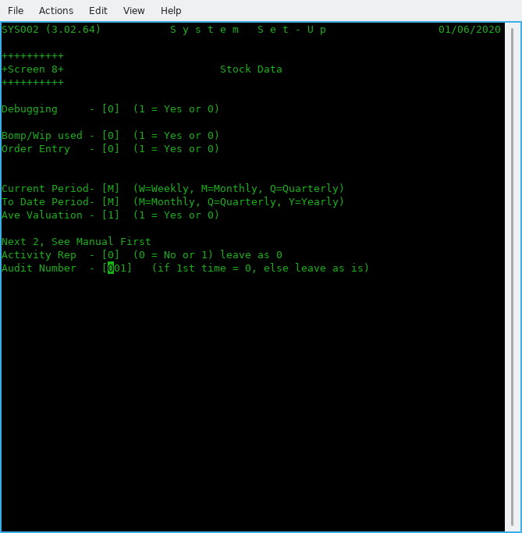

Figure 6.11 Screen 8 - Stock Control

See the ACAS - Stock Control System manual for more information on these, if needed.

(8-01) Debugging
Unless requested by ACAS technical support, leave this as 0.

(8-02) Bomp/Wip used

Set to 1 if you need Bill of Materials Explosion / Work In Progress functionality. Otherwise set to 0.

(8-03) Order Entry

Set to 1 if using the Order Entry system. [Not for the O/S version, so is set to 0.]

(8-04) Current Period

Declare what the reporting period is: M = Monthly (recommended), W = Weekly & Q = Quarterly.

(8-05) To Date Period

Declare what the 'To Date' Period is;. M = Monthly, Q = Quarterly or Y = Yearly
(Yearly is recommended).

(8-06) Ave Valuation

Set Average valuations on for current stock, otherwise you will need to maintain stock valuations yourself – a tiresome and possibly long winded and error prone process.

(8-07) Activity Rep

Set to 1 for recommended setting, and this produces reports for all stock movements (needed for Audit control).

(8-08) Audit Number

Start number. Set it to 0 unless system has been running then leave it unchanged.

On pressing return will ask you to confirm settings having displayed the summary details.

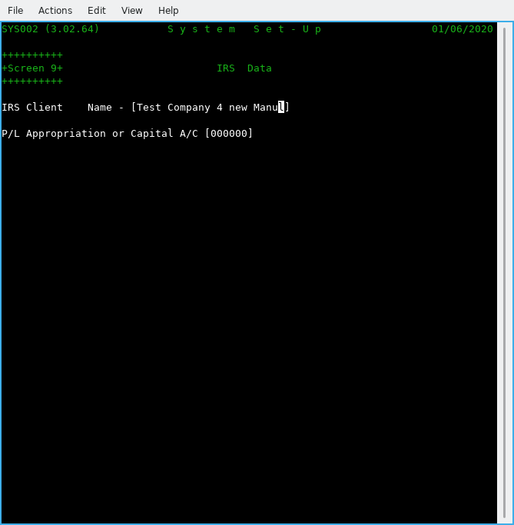

Figure 6.12 Screen 9 -- IRS Data.

Specific data for IRS as all other required data is taken from the previous screens.

(9-01) IRS Client Name

Enter the name of the client for the IRS system or use the name of the business / company as entered in 0-01 and this would be the normal entry unless you will use IRS for processing more than one company accounts. In which case this process has to be done for each, in their own folder / directory. If using the DB (database) option, then a unique DB must be created for each business.

(9-02) P/L Appropriation or Capital A/C

Enter here the IRS or GL account number for this account which if using the supplied sample IRS accounts would be more likely 000295. This is the account that will be used when running EOY (End of Year) processing at the end of the IRS menu option 7 ‘Accounts Production’ where it asks if you wish to run end of year. Here the system having cleared the posting file and reset all of the CoA (Chart of Accounts) will post OTB (Opening Trial Balance) entries for all the brought forward accounts. The account entered, is not checked that it is present. See the IRS manual for more information.

Now to print out the details of the parameter files for your records, so select Y.
Warning: This does not print out all the parameter file settings as there are a lot of them but does for all important one's.

Note that new parameters can be added to the data entry screens discussed in this chapter at any point during testing and upgrades that might not be detailed, see the README or Update notes regarding any such changes, although these days it is now very rare.

System Note:
As at the date of updating this document (see inside front cover) GL (General Ledger) does not function the same way at all as IRS, but just clears down the posting file at the end of each reporting period. This is the way it was designed but is not the way this author / programmer thinks it should work, and two additional programs may well be added to do this correctly, that will cover Final Accounts Setup and Reporting, and this after completion of testing v3.02 of IRS, PL, PL and Stock Control.

One additional program for sundry processing to support the processing of garbage collection (bad data recovery) will also need adding subject to Final Accounts processing. It might be necessary to add or change other processes that are missing or buggy in GL during unit and system testing.

Warning: GL has not had any testing since migration over to GnuCOBOL due to time constraints and the fact that IRS does all General Ledger processing but without the extra complexity of handling separate branch or multiple Profit Centre processing or for that matter, SCFP (Statement of Changes in Financial Position) which for the first two can be handled by the use of sub nominal accounts.

It is not being anticipated to rebuild the later, as most business will require the use of a CA (Chartered Accountant) to utilise correctly, and also requires updates subject to changes in government requirements for taxation which occurs each year around budget time and this applies for all countries.

Very similar to Payroll, in that both require continuous chargeable support through a yearly maintenance contract.

If you use an independent payroll package you can request that the facilities in ACAS are used to transfer the data to IRS (or GL) or even both using the previously discussed FH (File Handlers).

Therefore these options are not provided for the open source version of ACAS.

Sample ACAS Parameter File Set up Report
SYS002 (3.02.64) S Y S T E M P A R A M E T E R S 2020/05/31 Page 1

User Parameters G/L Parameters
**************** ****************

Name Test Company for new Manual Using IRS instead of GL - Yes
Address Any old Road Neither P/C or Branches Selected
Any Town

AA1 2BB, UK Comparative Figures Required
Company Email test-co-Purchase@gmail.com
Date Format Intl Format Alphabetic Ledger Index Selected
Period Start 2020/04/01 Statistics Year 2020 Full Validation During Data Entry
End 2021/03/31 Transactions Deleted at End of Cycle
VAT Rate 1/4. 20.00 / 0.00 VAT Reg: GB493123498 (P) Purchase Range most Significant Digit is - 1
Rate 2/5. 5.00 / 0.00 Purchase Range Most Signif. Digit is - 2
Rate 3. 0.00 Auto VAT Posting Selected
Current Quarter 1 Cycles per Quarter - 3
Current Cycle 1 Next Batch Number - 1
Print Lines 48

ACAS Parameters P/L Parameters
**************** ****************

Environment Multi User Address Delimiter !
Op. System Linux Next Batch Number 00000
System version Using (Free) Open Source Version of ACAS Next Folio Number 00000001
Cobol Data Files Used Pay Account 000000
Path to BIN /home/vince/bin Ledger Account 000000
Path to Ledgers /home/vince/ACAS/Building-Manual Creditor Account 000000
Prt Spool Name 1 Zfficejet_Pro_8600 Stock Control Link Yes
Prt Spool Name 2 Officejet_Pro_8600
Prt Spool Name 3 Officejet_Pro_8600

Inv. Parameters S/L Parameters
**************** ****************

Next Inv. Number 00000001 Computer Generated Invoice Numbers Selected
Dunning Letters Selected
Late Charges Selected
Inv. Data Level 2 Credit Period 30 Days
Standard Credit Limit 500
VAT Account 000000 Standard Discount is 0.00%
Print VAT Number Yes Min. Late Balance 0
Prt Inv Max Itms 25 Max. Late Charge 0
Late Charge Rate 0.00%
Address Delimiter !
Proforma Retent. 0 Next Batch Number 00001
Company Heads Print on Delivery notes: Y Stock Control Link Yes
Company Heads Print on Invoices : Y Pay Account 000000
Company Heads Print on Statements : Y Ledger Account 000000
Company Heads Print on Late Letters : Y Debtors Account 000000
SYS002 (3.02.64) S Y S T E M P A R A M E T E R S 2020/05/31 Page 2

Stock Parameters IRS Parameters
**************** ****************

Debug Mode No IRS Client Test Company for new Man
Manufacturing No
Audit in Use Yes
Movement Audits Yes
Current Period Monthly
To Date Period Monthly
Stock Averaging Yes
Current Audit No 00000001

Payroll Parameters RDMBS Parameters
****************** ****************

Payroll in Use No

System Parameters
*****************

PL Approp A/C 000000

End of System Parameter Report
==============================

Note that the items listed here are correct for this version, and later one's can have extra fields added that are printed. The above is NOT a complete list of all parameters in use.

Analysis Recording and Reporting Set up - option L.

Having set up the system parameter data, it is necessary to also run the Set-Up Purchase Analysis Codes process option L from main menu and having selected this, it will first create the default codes required for both S/L and P/L. and this step may be run in Sales Ledger but both do exactly the same, setting up the default analysis codes.]

You should select print to get a hard copy then providing you have set up the CoA (Chart of Accounts) in IRS or GL or both, run the Amend process and update the current zero default GL codes with the correct one’s to be used and without doing so will result in false information on some reports.

It is not possible to predefine these, as there are too many variables for the system to guess at the one’s you would select to be used, but it does give you the opportunity to add to the CoA, more accounts to satisfy your needs even for the future.

At the same time you can add additional codes that you wish to use but there is no rush to do so unless you require more control over the analysis process.

The usage beyond the default codes being set up, is totally optional.

See the sample report next, and the report is exactly the same for both P/L and S/L with only the program names and version numbers changed.

Sample report from PL070 option L:

PL070 (3.02.20) Product Analysis Codes Page 1

Applewood Computers 25/08/2025

Lgr Code GL.No. <-----Description------> Print -Type-

P a 000000 Default Group Group
a1 000000 Default Purchases Detail
a2 000000 Purch for Stock Detail
a3 000000 Purch for Office Furnit Detail
a4 000000 Purch for Office Consum Detail
a5 000000 Purch for Office Equipmt Detail
a6 000000 Purch for Office Autos Detail
a7 000000 Purch for Travel Detail
za 000000 Purch Carriage Charges P&P Detail
zb 000000 Purch Late Charges LCG Detail

S a 000000 Default Group Group
a1 000000 Default Sales Detail

S v 000000 VAT Control Group
vi 000000 VAT Input Invoices/CN's Detail
vj 000000 VAT Input Receipts Detail
vo 000000 VAT Output Invoices/CN's Detail
vp 000000 VAT Output Receipts Detail

S z 000000 Computer Control Group
zc 000000 Sales Carriage Charges P&P Detail
zd 000000 Sales Late Charges LCG Detail

Warning: One or more P.A. codes contain a zero value for IRS / GL numbers

The General Ledger Interface

The P/L (Purchase Ledger) system, functions equally well as a stand alone system or with the ACAS IRS (or General Ledger). Hereafter just called GL. If the GL is used, the P/L system will produce posting records into the GL posting file that contains accumulated and summarised accounting information providing the GL link is set to 'Y' in the system parameter file.

Every time the transaction or payment posting programs are run, the GL posting file is updated to reflect the new activity posted to the open item or payment files. The differences between IRS and GL is :

- When IRS is run, the user selects menu option 4 Posting, then selects option 66 'Add SL or PL Postings from file' and IRS posts to the accounts the values from each posting record before clearing down the file having made a copy of each posting to the IRS posting file. The posting file is retained for the whole of the financial year. GL currently clears the posting file after every quarter and all current figures on the accounts are then brought forward figures. No, I do not like it this way and I suspect accountants will not as well - another reason to not use GL but stick to IRS instead.

- When GL is run the user selects menu options F, G & H to proof, report and post all postings and transfers the net of all activity on to each account.

For IRS or GL this process removes the need to process P/L or S/L transactions individually hereby reducing work load and costs which for a busy office can be considerable. Within IRS, a option is used to post this data file but within GL as the main GL posting file is used, the posting function will also process records added by PL or SL.

In practice, there can be several sales and purchase accounts since some businesses separate their sales and purchase into categories to keep closer watch on which products, departments, or regions are performing exceptionally or not. In addition, one purchase account is usually a asset or liability account, Accrued Vat Payable. Special accounts may also be required for such things as a consignment purchase. In this case the purchase may be partially credited to an S/L (Sales Ledger) account. This is a simplification of what can be a more detailed subject area.

The Supplier Record - option B.

The supplier record, created and modified by the Supplier Entry and Amend programs, contain the name, address, phone, and credit information of all suppliers. Suppliers can also be added using the Transaction Entry program by selected the function key 'F1' during input or using NEW as the supplier number. The same file can also be used for the issuing of receipts for prepayments such as supplied proformas. Any proformas can be converted to a receipt by a simple process that does not require the entire order being entered again once payment has been confirmed as sent by just changing the transaction type from proforma to receipt during order amend.

Before a Purchase order can be placed on the system, an account must be established for the supplier by entering the name and address information using the Supplier Entry program . This allows the user to assign the supplier a six character supplier number of the form:

cxxxxxq

where "c " can be A – Z or 0 – 9 which can represent a supplier type, region/location etc., "xxxxx" is a unique five digit account number or even letters, and "q" is a single check digit used to protect against transpositions and key errors if using numbers only. One or more letters can be allocated to signify that the supplier is a cash only supplier and/or proformas are always issued etc.
When adding a record, the Supplier Entry program displays the new supplier's number with the check digit added and requests information relating to the account. In addition to the name and address, whether the supplier issues late charges levied on unpaid invoices as well as a minimum amount outstanding before late charges are added, a maximum late charge amount, credit period, Discount % off all invoices, Email preferences for sending orders, etc., as well as recording telephone and fax contact information along with space for additional notes and other information not mentioned here.
The entry is complete once a Escape code (see bottom right of screen) is entered which is S to Save, B is Back to beginning or Q to Quit the entry program.

Each supplier may be allocated a credit limit value that they have supplied to your business between zero and 9,999,999. Whenever the outstanding purchase balance exceeds the supplier's credit limit, an identifying flag is printed on the Trial Balance reports next to the supplier's name. This is also checked and if needed a warning displayed during transaction Entry if the limit will be exceeded which indicates that a payment should be made. A system wide default credit limit is established on the system parameter file that can be changed for each supplier as desired. Do not enter the commas, so from the above only enter 9999999.

When using rdbms and more than one user is inputting transactions and two or more are processing for the same supplier the active balance may not be up to date at a given point in time so the check may pass when a minute or two later it would not. It is not recommended to have more than one transaction input stream at a time for this reason.

See Figure 7.1 for the Supplier Entry screen.

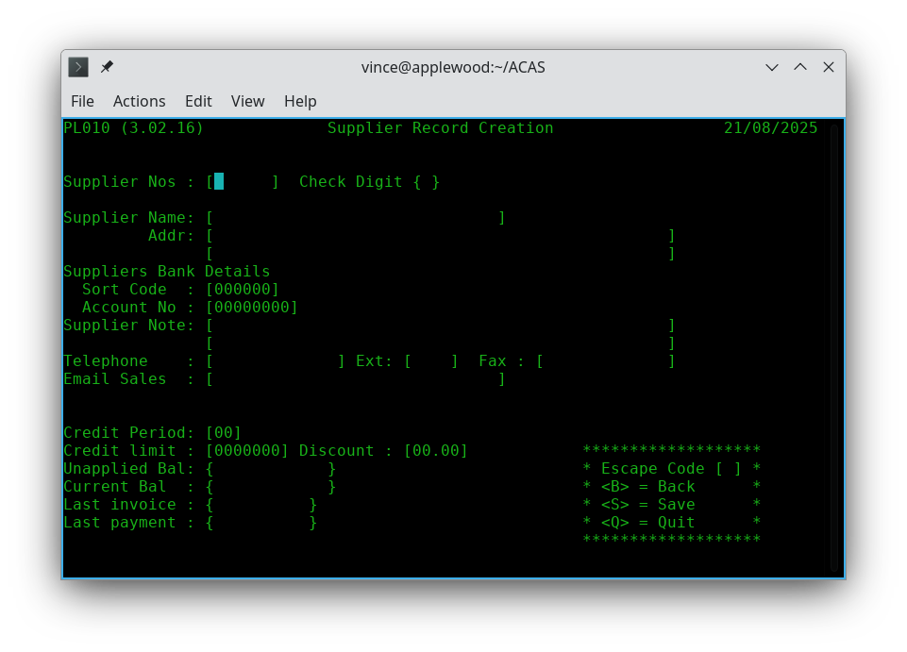
Figure 7.1 Supplier Entry screen

When entering the address details the usage of the delimiter character as defined in the Setup Parameter file is compulsory as failure to follow this will result in an error message, for example here is a valid address:

Line 1: Attn: Mr Fred Bloggs,!Applewood House,!Epping Road,!Roydon!
Line 2: Essex, CM20 1AA

Note that here the postcode / zipcode is added preceded by a comma and space.

When you wish to close a supplier account, the delete function removes the record from the supplier file. Before deleting a record be sure there are no active payment records or open purchases / transactions for that supplier however the system should prevent you from doing so. Clearly if there are outstanding transactions or invoices and you still need to delete the supplier you must credit off all such transactions however it is recommended that such suppliers are left on the system but with their credit rating reduced to zero and a note added to the account specifying what has happened as a reminder for all staff.

Each suppliers number contains a check digit as the last digit which is a number calculated on the basis of the other digits in the supplier number. The selection algorithm for the check digit enables almost all key entry or transposition errors to be detected instantly. All calculations are done automatically by the system.

The Supplier Print programs

The various Supplier Print programs may be run at any time. The programs produces an ordered listing of the data in the supplier files. You can change the form of the report by selecting any of the report attributes as shown in figure 8.1 below and this capability is available for most of the reports throughout ACAS (the Applewood Computers Accounting System).

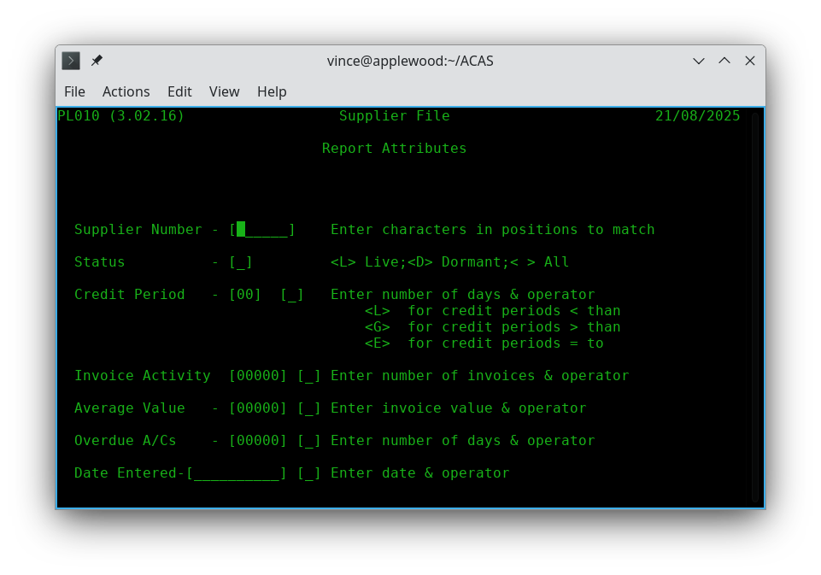
Figure 8.1 Report selection Criteria request

All entered criteria will be tested for, prior to printing.

Sample printouts are shown in Figures 8.2 to 8.4. The supplier print is a handy reference when printed in supplier name order, allowing cross referencing between name and number.
The Alphabetic ordered print is listed by supplier name and the last report is a Supplier file Dump which prints out all information for each supplier and this one is not commonly used except may be as a back up. Note that this report, also shows the address delimiters.

The sample alphabetic report shows the problems that you might be faced with if you do not have a procedure in place as to how the name and address data is entered, i.e., do you want the business name or the contact name as the supplier name that is sorted or otherwise shown. If business name. than on the first line of address you might want the contact name if provided before the rest of the address and with if needed, a comma followed by the post or zip code.
This, applies equally if not more so to sales ledger as well. To be also considered (and using the sample data reporting in this manual is case as for some of then they were entered all in upper case (capitals). Likewise the use of titles other than Mr, Mrs, Miss etc. i.e., can you avoid job titles as over time they can change so not using them removes the need to change the address information just because of that - assuming it is noticed of course.

These sample records are from test data only, loosely based on available information from over 40 years ago.

Figure 8.2 - Supplier Reports (all in landscape):
PL010 (3.02.16) Supplier Listing Page 1
Applewood Computers Report On : All 21/08/2025

Supplier Status <----------------Name & Address----------------> ----Telephone---- -----Fax----- ----Credit---- Discount
Number ------ Limit Period %

PA00011 Active Mr. K. Farmer 01554-6262 10000 30 40.00
Moldavia Ltd,418-420 Cranbrook Road,Gants Hill,Ilford,Essex

PA00029 Active Mr. S. R. Colman 01554-4164 10000 30 40.00
Anco Computer Services Ltd,4 Benton Road,Ilford,Essex IG1 4AT

PA00037 Active Mr. H. Curtis 01518-0226 10000 30 40.00
FCA Computer Services Ltd,418-420 Cranbrook Road,Gants Hill,Ilford,Essex

PA00045 Active University of Oxford 086581-7728 10000 30 40.00
Dept Obstetrics&Gynaecology,John Radcliffe Hospital,Headington,Oxford OX3 9DU

PA00053 Active Mr P Y Mills (M D) 012488-895 10000 30 40.00
Intercompany Communications,Techology Ltd,76 Cannon Street,London EC4N 6AE

PA00061 Active B.Walist 22-5375 10000 30 40.00
Harry Mitchell & Partners Ltd,P.O. Box No 2,Beeston,Nottingham

PA00070 Active Mr J Creutzberg 01223-7730 10000 30 40.00
OFF Records,Computer House,58 Battersea Rise,Clapham Junction,London SW11 1HH

PA00088 Active Mr Sutherland Ext.3198 031337-2442 10000 30 40.00
Ferranti Computer Systems,St Andrews Works,Roberston Avenue,Edinburgh,EH11 1PX

PA00100 Active Mr Mills 077273-5753 10000 30 40.00
Preston Borough Council,Preston ITeC,Lanceshire House,Watery Lane,Preston PR2 2XE

PA00118 Active Strathclyde Regional Council 041429-7767 10000 30 40.00
Glasgow Coll. of Nautical Std.,21 Thistle Street,Glasgow G5

PA00126 Active Mr J.H.Lawrence 045432-1088 10000 30 40.00
Lawrence Associates,10 Somerset Avenue,Yate,Bristol BS17 5SF,Avon

PA00134 Active D Woods 027944-3561 10000 30 40.00
Daro (Office Furniture) Ltd,Daro International House,East Road,Templefields,Harlow CM20 2BJ

PA00151 Active P.Copin 071813-861 10000 30 40.00
I.PH.I.B.,I.Ph.I.B. c/o I.R.E,Batiment 9,Service D,6220 Fleuris Belgium

PA00177 Active Mr R.G.Ellen Ext.261 02066-9222 10000 30 40.00
Lloyds of London Press,Sheepen Place,Colchester,Essex CO3 3LP

- - - cut - - -

PL010 (3.02.16) Supplier Listing Page 80
Applewood Computers Report On : All 21/08/2025

Supplier Status <----------------Name & Address----------------> ----Telephone---- -----Fax----- ----Credit---- Discount
Number ------ Limit Period %

PP00639 Active Mr D.M Grech 356511-143 10000 30 40.00
Telamon Ltd,7 Ponderosa Court,Mrabas Street,St Julians,MALTA

PP00647 Active Mr F.J Hunter 020425-396 10000 30 40.00
Advanced Computers Ltd,27 Doe Hey Road,Bolton,Lancashire,BL3 2LW

PP00655 Active Mrs S. M Walton 044277-4881 10000 30 40.00
Castle Business Systems Ltd,ECL House,Park View Road,Berkhamstead,Hertfordshire HP4 3EY

Figure 8.3 - Alphabetical Supplier List

PL160 (3.02.06) Supplier Alphabetical Listing Page 1
Applewood Computers Report on : Matched 21/08/2025

Supplier Status <----------------Name & Address----------------> ----Telephone---- ----Fax--- ----Credit---- Discount
Number ------ Limit Period

PA20992 Active A Butler 046267-0468 10000 30 40.00
Froscroft Ltd,12 Lapwing Dell,Letchworth,Herts SG6 2TE

PA16154 Active A Christopher 020439-7838 10000 30 40.00
Broadsword Systems Ltd,Park View House,179b Chorley New Road,Bolton BL1 4QZ

PA18131 Active A D Stiegler 01979-5537 10000 30 40.00
A.D. Stiegler,121 Hanworth Road,Hampton,Middlesex

PA10695 Active A F Broughton (MD) 062355-3436 10000 30 40.00
H.N & L Fisher (Huthwaite),264 Huthwaite Road,Sutton in Ashfield,Nottinghamshire,NG17 2HG

PA16243 Active A G Johnston 073235-3069 10000 30 40.00
C-Matic Systems Ltd,Rocks House,Stone Cross,Crowborough,E Sussex

PA16715 Active A H Wells 052528-774 10000 30 40.00
ABC Computers Ltd,Systems House,Houghton Parade,Dunstable,Bedfordshire LU6 1DA

PA13228 Active A J Clewett 021443-4392 10000 30 40.00
Cle.Com Ltd,Kings Court,92 High Street,Kings Heath,Birmingham B14 7JZ

PA19323 Active A L Wood 01546-2984 10000 30 40.00
Microprocessor Support Ser Ltd,48 Eaton Drive,Kingston,Surrey,KT2 7QX

PA16685 Active A Morgan 063261-0871 10000 30 40.00
Newcastle Health Authority,Supplies Division,10-12 North Terrace,Newcastle Upon Tyne,NE2 4AD

PA13597 Active A R Lamont (MD) 042879-3636 10000 30 40.00
Crown Management Systems Ltd,Beech House,Ballsdown,Chiddingfold,Surrey GU8 4XJ

PA11811 Active A. Murray 028123-865 10000 30 40.00
MBS Soft,Unit A,Horton Trading Estate,Stanwell Road,Horton, SL3 9PF

PA10148 Active A. Perkins 09325-3488 10000 30 40.00
Perkins A.,Microfin House,,Chapel Grove,,Addlestone,,Surrey, KT15 1UG

PA08399 Active A. Vaughan 021472-1301 10000 30 40.00
University of Birmingham,,Dept. Immondogy,The Medical School,,Birmingham,,BTS 2TJ

PA10351 Active A.A. Wilson 059073-322 10000 30 40.00
H. Jones Chartered Accountants,Lymington House,,73 High Street,,Lymington,,Hamps., S04 9ZA

- - - CUT - - -

PL160 (3.02.06) Supplier Alphabetical Listing Page 80
Applewood Computers Report on : Matched 21/08/2025

Supplier Status <----------------Name & Address----------------> ----Telephone---- ----Fax--- ----Credit---- Discount
Number ------ Limit Period

PA07058 Active Wordsmiths 045845-359 10000 30 40.00
West End St.,Somerset,BA10 0LQ

PA07708 Active Yvonne Lyons 032286-2181 10000 30 40.00
Microsource Ltd,Lyons House,9 New Road,Rochester,Kent Me11 1BG

PA07180 Active Zenner Enterprises Ltd 095973-383 10000 30 40.00
267 Main Rd,Biggin Hill,Kent,TN16 3CA
Figure 8.4 - Supplier file dump

PPL190 (3.02.06) Purchase Ledger Dump Page 1

Applewood Computers Report On : All 21/08/2025

Purch-Key PA00011 Purch-Credit 30.00 Purch-Current 0.00
Purch-Name Mr. K. Farmer Purch-Discount 40.00 Purch-Last 0.00
Purch-Addr1 Moldavia Ltd!418-420 Cranbrook Road!Gants Hill!I Purch-Notes 00 Turnover-Q1 0.00
Purch-Addr2 lford!Essex Purch-Average 0.00 Turnover-Q2 0.00
Purch-Phone 01554-6262 Purch-Limit 10000.00 Turnover-Q3 0.00
Purch-Fax Purch-Activety 0.00 Turnover-Q4 0.00
Purch-Status Live Purch-Last-Inv
Purch-Email Purch-Last-Pay
<-------------------------------------------------->

Purch-Key PA00029 Purch-Credit 30.00 Purch-Current 0.00
Purch-Name Mr. S. R. Colman Purch-Discount 40.00 Purch-Last 0.00
Purch-Addr1 Anco Computer Services Ltd!4 Benton Road!Ilford! Purch-Notes 00 Turnover-Q1 0.00
Purch-Addr2 Essex IG1 4AT Purch-Average 0.00 Turnover-Q2 0.00
Purch-Phone 01554-4164 Purch-Limit 10000.00 Turnover-Q3 0.00
Purch-Fax Purch-Activety 0.00 Turnover-Q4 0.00
Purch-Status Live Purch-Last-Inv
Purch-Email Purch-Last-Pay
<-------------------------------------------------->

Purch-Key PA00037 Purch-Credit 30.00 Purch-Current 317.15
Purch-Name Mr. H. Curtis Purch-Discount 40.00 Purch-Last 0.00
Purch-Addr1 FCA Computer Services Ltd!418-420 Cranbrook Road Purch-Notes 00 Turnover-Q1 275.00
Purch-Addr2 !Gants Hill!Ilford!Essex Purch-Average 137.00 Turnover-Q2 0.00
Purch-Phone 01518-0226 Purch-Limit 10000.00 Turnover-Q3 0.00
Purch-Fax Purch-Activety 2.00 Turnover-Q4 0.00
Purch-Status Live Purch-Last-Inv 19/08/2025
Purch-Email Purch-Last-Pay
<-------------------------------------------------->

Purch-Key PA00045 Purch-Credit 30.00 Purch-Current 0.00
Purch-Name University of Oxford Purch-Discount 40.00 Purch-Last 0.00
Purch-Addr1 Dept Obstetrics&Gynaecology!John Radcliffe Hospi Purch-Notes 00 Turnover-Q1 0.00
Purch-Addr2 tal!Headington!Oxford OX3 9DU Purch-Average 0.00 Turnover-Q2 0.00
Purch-Phone 086581-7728 Purch-Limit 10000.00 Turnover-Q3 0.00
Purch-Fax Purch-Activety 0.00 Turnover-Q4 0.00
Purch-Status Live Purch-Last-Inv
Purch-Email Purch-Last-Pay

- - - CUT - - -

PL190 (3.02.06) Purchase Ledger Dump Page 278

Applewood Computers Report On : All 21/08/2025

Purch-Key PP00655 Purch-Credit 30.00 Purch-Current 0.00
Purch-Name Mrs S. M Walton Purch-Discount 40.00 Purch-Last 0.00
Purch-Addr1 Castle Business Systems Ltd!ECL House!Park View Purch-Notes 00 Turnover-Q1 0.00
Purch-Addr2 Road!Berkhamstead!Hertfordshire HP4 3EY Purch-Average 0.00 Turnover-Q2 0.00
Purch-Phone 044277-4881 Purch-Limit 10000.00 Turnover-Q3 0.00
Purch-Fax Purch-Activety 0.00 Turnover-Q4 0.00
Purch-Status Live Purch-Last-Inv
Purch-Email Purch-Last-Pay
<-------------------------------------------------->

Order Transactions

The Order Transactions Batch
Financial transactions in the Purchase Ledger system go through two stages. Before posting they are considered batch transactions. After posting, transactions are considered posted or permanent entries. Batch transactions are unofficial and thus can be added to, changed, or deleted at any time without any record keeping requirements. Once the batch of transactions is posted, however, they become permanent entries that require standard accounting procedures to modify or delete. These standard procedures leave an audit trail that can be used to trace a transaction through the system.

There is only one transactions batch at any one time. This batch remains current until posted to the open item file by the transactions posting program. When the transaction entry program starts, it examines the system to see if there is a current invoice batch. If one is present, the program allows it to be modified or added to. If no current batch exists, one is created. Batching is totally transparent to the user. The term batching is just a holding process for where the pre-posting transactions are held.

The number of PO's (purchase orders) allowed on the system per supplier is limited only by the amount of disk space available. The same applies to the number of suppliers. See the appendixes for record size information on the primary files or rdbms tables. We have commercial users who have in excess of 1,000 suppliers although many are not active and produce well in excess of 100 purchase transaction orders per week. Holiday periods such as Christmas time, these number can be larger.

The purchase ledger system support data entry via purchase orders (sent to the supplier manually, etc.) from the PL team or via invoices or packing notes received from the supplier that have been verified by goods inwards personnel where any differences are noted on the paperwork and then entered into the PL system so that payments can be generated at or around the credit limit period or one specified by the user. Hence the reason for the input procedure allows for fields - folio, Invoice, and purchase order numbers and all three can be part of transaction data entry.

Prerequisite Settings

You have to set up the order transaction system via menu option U and sub-option 1 (Amend Transaction Fixed Data) adjusts the folio number value according to your needs but otherwise starts from 1 (figure 9.1):
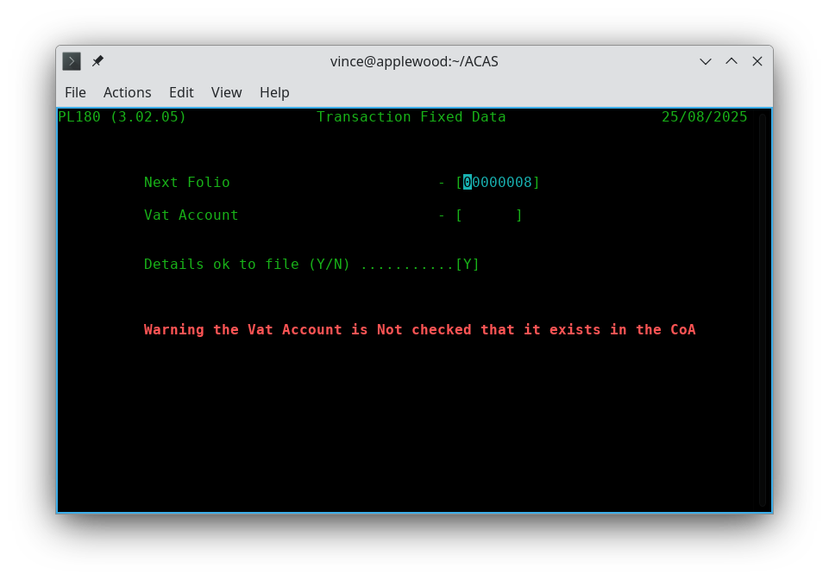
Figure 9.1 Invoice (Transaction) settings

Lets quickly go through these in order:

- Next Folio Number: Set this as needed, but not less than 1. This is auto allocated when entering transactions then incremented by 1 for every entry. Should a transaction be deleted these are reused in lowest numerical order.
- The last one is for entering the IRS (or G/L) nominal or sub nominal account that relates to Vat so that the accounts are always up to date without the need to enter this type of information into IRS manually.
- And the last one, 'Y' to confirm all of your settings otherwise 'N' to go back through the screen. Of course you can just enter Y and reselect the screen to go through it again updating previous data.

The next and last option is Recurring transaction processing. See later for more information.

Using the Order Transaction Entry program

When you select Transactions Entry from the system menu, the Order Entry screen appears as in Figure 10.1 with· the cursor waiting at date where you can change it if needed, otherwise press enter or tab

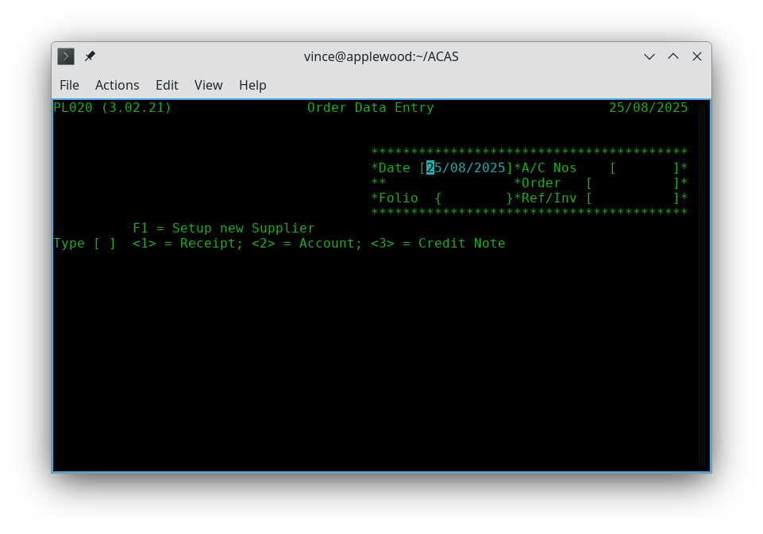
Figure 10.1 Order Entry - Supplier a/c details etc.

to move to the supplier account number field. You now enter the supplier number or if this is a new supplier you can press the F1 function key (or enter 'NEW' as the supplier number). If you have selected F1 (or NEW), you go through the normal process to create a new supplier account and after saving the data will go back to this point. So having entered the account number then pressing return it brings up the name and address details for the selected account. If you keyed in an incorrect account you remain on the account field so re-key the account and the cursor moves to the next field - Order (PO) number if applicable if not, leave blank, now when pressing tab the folio is updated for you and now you can enter the Invoice or reference number. You can use the tab key to change to the next one or back tab (up arrow and down arrow keys also work), Next field is you need to select what type of entry this is, e.g., 1 = Receipt, 2 = On Account (credit) or 3 = Credit note (for a existing transaction).
Receipt is a prepaid receipt / invoice.
Account is for suppliers you have an account with.
Credit (Debit) note is where you need to clear elements of a previously entered and posted transaction and this will act the same way as a payment by clearing down in part or all of a posted transaction.
At this point the screen changes (see fig 10.2) where you can enter all line items.

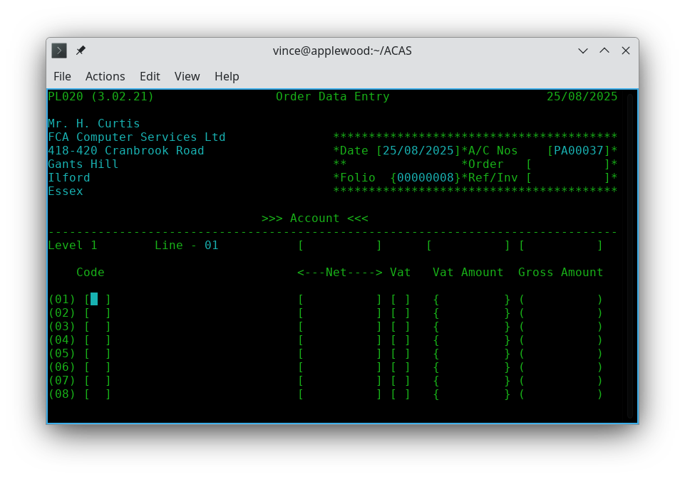
Figure 10.2 The Order body enter screen

Transaction Order Line Items

The normal transaction processing flow, is having set up the folio number parameter via menu option 'U' sub option 1, is to Enter, Amend, Delete, Proof and then Post via the main menu options C through H.

The number of line items that can be used per transaction PO is limited to 40. For most businesses they, create a new purchase order way short of this number.

To Enter or process the maximum line items per screen it is recommended to set the size of the terminal program you use to run ACAS to 80 columns wide.
Any length or depth, as long as you would like, e.g., 40 lines by 80 columns and on a A4 screen in portrait mode 90 lines by 80 columns will also work. ACAS reads the size of the terminal screen when loading and adjusts data displays and input for the length. It cannot adjust for width as it would cause more problems than it fixes.

Note that if you change the terminal size after ACAS has loaded it will not re-read the size as the changed information is not available as it is only read by each program when first started.

To continue :

Starting with analysis code enter the correct code and this is case sensitive (i.e., upper and lower is NOT the same) and this is checked against the one's stored in the analysis file. If it is wrong you will get a message to that effect and can re-enter the correct one and here it is useful that a full list of these codes is available to the person entering purchase ledger data.
If you press the Escape here, you will go to the additional information screen.
You can enter '<<' to go back one line, i.e., the previous line entry and if it is the first line will ask for the analysis code again.
If the line just entered, is in error due to a keying mistake and you only notice it after, when on the next new line you can enter << at the analysis code, to go back one line, you can do this continuously to get to a previous line up to the first line.

After a valid code has been entered the description for it is next shown and the cursor then moves to net amount after entering that one, Vat (sales tax) is the next and here the options are 1, 2 and 3 and Vat standards options S = Standard (1), R = Reduced (2) and Z = zero (3) rates. The default is S for standard rate and is shown on screen, if you just press return, otherwise change it.

Next is displayed the Vat amount that can be changed or just return to go to the next one, for which gross amount is displayed for your information. A running total is displayed above the line items for your reference. If you space fill then press return or hit the Escape key at the start of a new line you will go to next screen (figure 10.3) for the additional amounts.

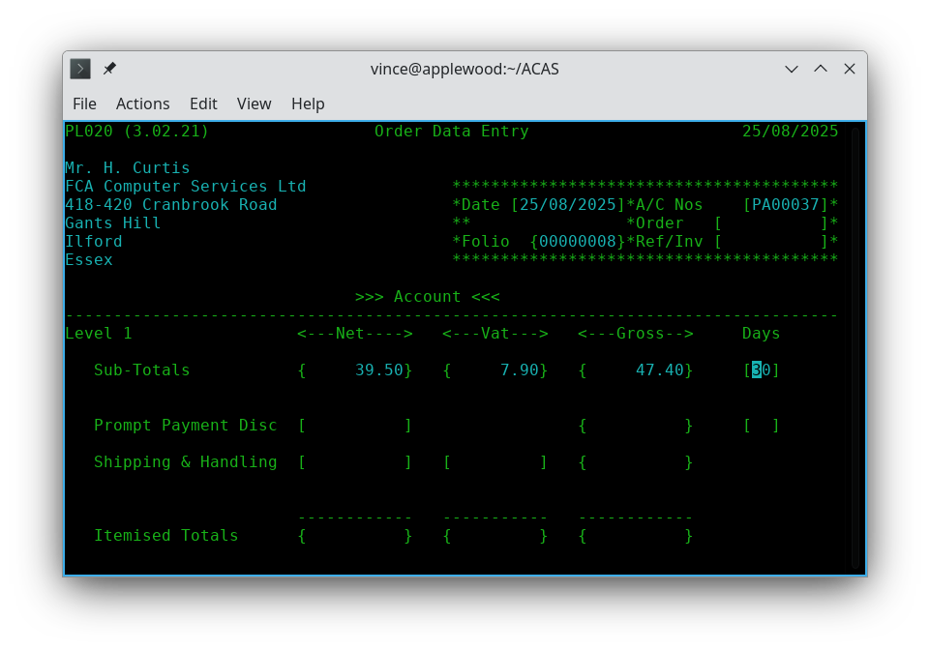
Figure 10.3 Order Entry – Sub totals,postage & prompt payment discount

Now to finish off the order you can change the default credit period in days and down arrow or return goes to the next line in this case Prompt payment discount (if any) along with all its details including the number of days (most important as payment generation relies on this figure), next is 'Shipping & Handling' where you can now enter these figures or by using the return or down arrow keys to accept the displayed amounts.
After which you are asked to confirm everything is correct and that it is OK to save. If not enter N and this screen will restart using the previously enter data that you can amend. If it is correct entering 'Y' will save it and you will be asked if there are more orders to enter and if so screen 10.1 will be redisplayed to enter more orders, otherwise you will be returned to the menu.

During entry, all the normal control keys can be used (return, down arrow etc.) to position the cursor including backspace to erase the character under the cursor. The function of the control keys and what is available does depend on your systems (Linux, Unix, Mac OSX, Windows etc.) settings so you may need to change them for all to be available.

How to Add Order Transactions to the batch - option D.

This is exactly the same process as for normally entering transaction orders. Whether transactions are entered in one session or hours, minutes or even days latter the same function is used and new orders are added to the transaction batch and this continues until you proof and post the entered order transactions, credit notes, receipts, etc.

You should always run a proof before posting as it might save you the effort of having to raise a credit note for an transaction because of a silly mistake. You should try to avoid deleting an transaction even if only to keep the audit records clean. However deleting a transaction will result in the folio number being saved and reused during the next order entry session whether it be now or at a later date.

How to Change Transaction orders in the Batch - option E.

To change transactions while still in the batch state, select 'Purchase Transactions Amend' from the main menu. You will need to know the order number. You will see the same screens as for transaction entry the existing information will be displayed allowing you to change any of the fields including the supplier account number. The other options are to raise a credit note against the incorrect item lines, or to delete the incorrect transaction and totally re-enter it.

How to Delete Transaction orders in the Batch - option F.

For this you will need a proof report via option G as you will need the folio number but otherwise it is straight forwards as you are asked for its unique number.

How to Examine Invoices in the Batch

The simplest way is to produce a transaction proof report, which has to be done anyway, prior to posting them. You can also run any of the detailed supplier reports such as options O (Day report), P - Aged Creditors report. Option R - Turnover report does not go into such detail.

To examine a specific transaction, select the transaction amend option D from the system menu, and when the entry screen appears enter the folio number and thereafter keeping pressing return to move forwards through the transaction / order until you reach the one you want make any notes then exit the process via the Escape key.

How to save Records to Disk to Prevent the Accidental Loss of Data

The only way is to leave the Purchase menu by entering 'X' at the menu prompt, this will run a backup before returning to the command prompt. At this point you can rerun Purchase or any other systems in the normal way. That said, leaving any program will have closed all data files which saves all data currently in the programs buffers.

The Transaction Proof - option G.
The transaction proof is a formatted hard copy report on the current order batch. A sample proof is shown in Figure 11.1. The data for each order and the line items is printed in the order it was entered. The order proof serves as a working report and as an integral part of the PL system's audit trail.

While the order batch is being build, the order entry program can be ended at any time, and a proof report printed. This working proof can be used to verify the accuracy and completeness of each order. As many proofs as desired may be made.

A final proof must be taken immediately before the batch is posted. This final batch proof is a hard copy link in the audit trail that shows the exact transactions that were part of the batch when it was posted to the open item file. This printout is the only hard copy report that shows line item details for each transaction. If this final proof is not made, the order posting program displays a error message and requests confirmation. The program can be stopped and the hard copy proof taken.

The last page of the order proof report includes account totals. You will need this report to make any amendments, should it be needed.

A sample printout of this summary total page is also shown in Figure 11.1.

Figure 11.3 Transaction orders Proof Report

PL050 (3.02.07) Unapplied Purchase Transaction Report Page 1
Applewood Computers 25/08/2025

Number ---Date--- <------------Supplier------------> --Type-- Goods <---Net--> <---Vat--> <--Gross->

6 21/08/2025 PA00037 Mr. H. Curtis Invoice 20.00 20.00 4.00 24.00
Analysis a1 Value 20.00 Vat Code 1

7 21/08/2025 PA00037 Mr. H. Curtis Invoice 130.00 130.00 26.00 156.00
Analysis a1 Value 125.00 Vat Code 1
a1 5.00 1

8 25/08/2025 PA00037 Mr. H. Curtis Invoice 39.50 39.50 7.90 47.40
Analysis a3 Value 17.50 Vat Code 1
a4 22.00 1

PL050 (3.02.07) Unapplied Purchase Transaction Report Page 2
Applewood Computers 25/08/2025

Goods Carriage Net Vat Gross Prompt Pay

Total Receipts 0.00 0.00 0.00 0.00 0.00 0.00
Total Invoices 189.50 0.00 189.50 37.90 227.40 0.00
Total Credit Notes 0.00 0.00 0.00 0.00 0.00 0.00

V.A.T. Reconciliation Receipts Invoices Credit Notes

Vat Code 1 20.00% 0.00 37.90 0.00
Vat Code 2 5.00% 0.00 0.00 0.00
Vat Code 3 0.00% 0.00 0.00 0.00

Posting the Transaction Batch - option G.

Once the Orders batch is accurate and complete, it can be posted to the open item file. The open item file is the master file of all purchase orders due and unpaid. An order is not considered a permanent transaction until posted.

If the batch file has not been completely proofed, the transaction batch posting program prints an audit proof report however it does provide additional information and this should also be retained for the audit trail as it shows the folio order number.

Figure 12.3 Purchase Orders Posting Report:

PL060 (3.02.10) Purchase Orders Posting Report Page 1
Applewood Computers 25/08/2025

Number Date <------------Supplier------------> Type Old Balance New Balance Net Vat Gross

6 21/08/2025 PA00037 Mr. H. Curtis Invoice 317.15 341.15 20.00 4.00 24.00
7 21/08/2025 PA00037 Mr. H. Curtis Invoice 341.15 497.15 130.00 26.00 156.00
8 25/08/2025 PA00037 Mr. H. Curtis Invoice 497.15 544.55 39.50 7.90 47.40

Total Posted Receipts 0.00 0.00 0.00

Total Posted Folios 189.50 37.90 227.40

Total Posted Credit Notes 0.00 0.00 0.00

Un-Applied Credits C/F

The Payment Batch (manual processing)

Payment transactions go through the same batching procedure used for entering transaction orders. There is only one payment batch at any one time.

The payment batch remains current until posted by the payment posting program.

Applying Payments to Particular orders

Payments are applied to specific supplier accounts making use of the batch and item number as recorded by various reports and the folio number must be entered. Otherwise, the amount of the payment entering the system goes toward paying the earliest order on the account or is marked as un-applied. The order remains on the open item file, but is reduced by the amount of the payment. If the payment entry is greater than the amount of the order, the order is paid in full and the overpayment applied to the earliest pending order as usual. If no other orders for that supplier exist on the open item file, the overpayment is placed on the file as a credit balance un-applied, and remains until it is applied to an order.

Adjusting Entries

An adjusting entry is an internal transaction that credits a supplier account but does not involve an actual payment but uses un-applied payments previously applied to the supplier's account and that was more than likely caused by not having the correct order details for which it is to be credited at the time of entry. The adjustment is applied to a specific order. If the adjustment is not equal to the order amount it is handled as a regular payment of a non-matching amount.

In order to more accurately reflect returned merchandise and other transactions which should reduce purchase account balances, the correct procedure is to issue a credit note using the Transaction Entry program to offset against specific item lines in a specified order.

Removing Late Charges

Late charges may be removed for any supplier through the Payment Entry program . You do this during the entry to a particular order

Using the Payment Entry programs - options H and I.

When you select Payment Entry from the system menu, the screen appears with the cursor waiting at the supplier number field. Thereafter it is straight forward to go from field to field using the down arrow or return key. If you do not have an order to apply the payment against, you can leave it in the system as un-applied. The system reporting related to supplier accounts will show any such suppliers along with all outstanding orders so you can trace likely suitable orders to apply against.

How to Change Payment Receipt records on the Batch

To change payment transactions prior to payment posting, select the Payment Amend program from the system menu. When the entry screen appears enter the supplier and order details to amend, un-apply or delete. Note that payments can only be made to posted orders.

The Payment Proof.

The payment proof is a formatted report of the current payment batch file. A sample proof is shown in Figure 14.1. The data for each payment and adjustment is printed in the order it was entered. The payment proof serves as a working report and as an integral part of the PL system's audit trail.

While the payment batch is being built, the Payment Entry program can be ended at any time, and a proof report printed. This working proof can be used to verify the accuracy and completeness of each transaction. As many proofs as desired may be made.

A final proof should, be taken immediately before the batch is posted. This final batch proof is a hard copy link in the audit trail that shows the exact transactions that were part of the batch when it was posted to the system. This printout is the only hard copy report that shows account detail for each transaction. If this final proof is not made, the payment posting program displays a warning error message and will terminate.

The last page of the payment proof will report account totals.

If neither the IRS nor GL interface are selected, only totals of payments and purchase offsets are shown. If either option is selected, the total for each account specified is displayed alongside the account name and numbers. A sample printout of this summary total page is shown in Figure 14.1 or/and 14.2.

Figure 14.1 Payment Proof Report

Figure 14.2 Payment Proof Report
TO BE CREATED during system testing as needed.

Posting the Payment Batch

Once the batch of payments is accurate and complete, it can be posted.

If the batch file has not been completely proofed, payment batch posting displays an error message indicating that the audit proof has not been run and will abort. so you can run the proof report before returning to the posting step.

The posting of payments can be as frequent as needed, many times a day or daily etc., but must be done prior to producing Aged Trail Balance or similar reports.

Recurring Purchase Orders - options U, 9

NOTE These processes have not been written at this time as it is not expected to be wanted by ACAS users. However, any user can request that this function be added into the purchase ledger system by contacting the lead programmer as specified on the inside front cover of the manual.

Recurring purchase orders are orders that credit a supplier's account for the same amount each defined ordering cycle for such things, as property rent, equipment lease, loan payment, or service contracts. The orders vary only in the order (folio) number and the entry date.

The Purchase Ledger system provides for the creation and maintenance of recurring purchases through the Recurring sub-system (also known as Autogen), which is turned on by the actual entry of recurring orders. Likewise, it is turned off again, when there is no such orders in the system and this process will allow the order generating process to be run at specific points in the system such as prior to when normal orders are been posted.

Three programs are used to enter and maintain information on recurring Purchase, to proof the recurring entries and to post any such invoices that are due to be generated to the invoice file, ready for invoice proof and posting in the normal way.

Entering Recurring Purchases (PL810)

This program is entered via the Transaction sub-system option U, then selecting 9 for Recurring Transactions then 1 and this creates and maintains all information on recurring purchased. The program is almost identical in operation to the order entry programs described in Chapter 3.1. All functions, add, amend / change. delete, save, etc. are available. orders must contain the analysis codes and would normally, be items such as service items. All defaults are the same and may be overridden as desired. The program creates and maintains an autogen record rather than a normal order record but the data is more or less the same apart for some small additions, such as action date (instead of order date), order frequency and repeat count.

The process requests an entry date just as order Entry does. This date is never used as the order date, but it is placed in the autogen file as a reference for when the "master" recurring order is to be issued for the first occurrence, i.e., the start of the first cycle and is there after held as the date the order will be next issued and a copy of the date it was last issued.

The pricing used, is that on the date Autogen runs and that is currently on the stock record at the time.
Each such item must be in the Stock Control system and usually as a service (item).
Service items could also include such things as Post & Packing for various weights, i.e., up to 1Kg, 2 - 4.99 Kg, 5 - 9.99, 10 - 19.99 etc., where the costing includes costs of boxing, packing materials plus the actual courier change (ex VAT - where applicable).
The frequency for other services, which could include software such as monthly or yearly service fee's or rental, or support contracts, chargeable monthly or yearly. Hire of equipment, etc., the scope of this can be wide, and during the input of the autogen order you can specify the frequency where the date provided is the first date (in the future) when it will be applied, for the first time and all subsequent order generations will be on the anniversary of that initial date.

This will assume that the generate process will be run up to two days prior or two past for all such dates. The choice of using the last day of the month or the equivalent such as 30/mm/ccyy will act as the last day of month providing the current day is not less than 27th (to allow for February). However the best and safest form for this date usage, is when set to the 1st of the month and the process run up to two days before and after. This four day gap allows for weekends and short holiday periods. also see details of the posting program (3.7.3 on page 63).
This four day period gap can be changed via the PL830 program source code and then the system rebuilt but be very careful of doing such a change, as it might have adverse effects that are not wanted. The autogen system cannot cope with a business that totally closes for say a holiday of weeks where the period is within the first of the month and the four day gap, i.e., the 1st minus two and plus two days. If this occurs the next period will be missed for order creation.

The process does not request an order number since the master Purchase on the autogen file does not need one. Each order in the batch auto-generated from the master, is automatically assigned an order number as the next one in sequence, assuming you have the PL system set to auto create them and this is the recommended and practically the only way to, use it.
If any deleted order numbers exist, they are used first.

Proofing the AutoGen File - PL820

The Autogen proof program produces a report on the autogen orders as stored. In operation, the program is almost identical to order Batch Proof. This proof is not part of the audit trail and need not be run but very useful to confirm order settings and pricing and is therefore the recommended action and may be required for internal auditors if not others such as the sale team. It should be run at least monthly to confirm what recurring orders are still active along with the details for each.

Auto-Generating and Posting orders - PL830

The Autogenerate orders program can be executed once, for each monthly period. Although an autogen file may have entries for any valid period schedule such as monthly, quarterly or yearly, only those specified at the time it is run and due, are made into current orders on to the order file based on the next order date and frequency and the date the program is run allowing for the four day window as specified in section 3.7.1.

The Autogenerate orders program reads the autogen file, adding an order for each supplier's autogen entry (or entries) to the order batch for all valid periods as specified on the individual entry.

The Autogenerate orders program only uses auto created order numbers. It is therefore recommended to use the auto order number creation process as set up in the parameter file as option (5-09), see Parameter Set-up, from page 22 and a very good reason for such is the fact that this program can be run as a batch process outside of the menu cycle - more information on this later. This is, the default mode as this program is also run before the order posting program runs in the event it has not been manually run this month but does therefore assume that such a run occurs during the four day window.

The run date is used for the entry date field in each order record as it is transferred into the order batch file.

If the Autogenerate orders program has already been run this period and a order generated it will not be done again until the next defined cycle as specified in the frequency field during data entry.

Pre and Post Applied Reports

The Aged Trial Balance / Aged Creditor Analysis Reports - option P

The Aged Creditors report, is the most important internal report for the users of the Purchase Ledger system. The report shows the status of all purchase by suppliers, broken down into columns.
This reporting program (as all others), first asks for three pieces of information :
Report date, account numbers to match, and the minimum amount outstanding to report on.

A sample of the Detail Aged Trial balance is shown in Figure 15.1<<< ??? >>>. This report shows complete details for every supplier. Every outstanding order is shown along with any payments or adjustments applied in the last period. Each order amount is listed under a date column corresponding to the amount of time the order has been in the system. This is a lengthy, comprehensive report, that can serve as a primary working reference for your PL department throughout the billing period. CHECK THAT THIS IS TRUE FROM SAMPLE REPORT DURING SYSTEM TESTING.

All the reports show the supplier's number, name, and phone number. The detail reports show the following data for each item:

- The order number of each transaction. If the transaction is a payment, this is left blank, unless the payment was applied to a specific order. If the transaction is an adjustment, the characters "ADJ" appear. If the transaction is a late charge, the order number consists of the word "LATE".

- The date of the transaction. This is either the date it was entered onto the system by Payment Entry or order Entry or the date it was created if it is a system generated transaction such as a late charge or credit.

- The amount of the transaction. This prints in the column corresponding to the number of months etc., it has been on the system. The first column for one cycle, the second column for two, the third column for three and the fourth column for four or more cycles. The fifth column is for payments and adjustments.

- Un-Applied payment amount, Credit balance, and if over credit limit.

If you wish to print a report for a range of suppliers, enter the relevant criteria.

The report finishes with a total break down for all suppliers listed of :
Number Of orders
Amount Average O/S Amount Unapplied Cash
Payments Credit Balances Late Charges
No. of Live Accounts Number of Active Accounts % Active

and under Reconciliation Data provides :
Balance B/Forward Orders Posted Credit Notes Posted,
Payments Posted Pay Late Chgs Taken C.Notes, Late Chgs Taken
Balance C/Forward
and a warning if it is Out Of Balance.

Other reports available are :

Purchase Day Book
Supplier Turnover
Purchase Analysis

Payment System (auto)

Generate Payments to be made - Option 1

It starts by asking for the age to generate payments for so if using a 28 day cycle use 28 or if monthly and running on the last day of the month, use the days on the current month as a value. If you make payments more often such as weekly then enter 07 or if by weekly use 14 as the age.

Regardless of the entered value the system will look for order transactions that are equal or over that time period e.g., in the later case (14) for all orders placed that are not greater than 13 days old.

If fact it first starts showing a value signifying the number of days and if it is wrong enter N for the question 'is this correct (Y/N)' where you can enter the correct value. On first use it will offer the value 00 which implies to generate payments for ALL orders in the system which most likely is not what you want at all.

It will now generate payments that comply with the date period in days that you entered into the payment file with a report showing what was done.

Amend Payments - Option 2
Having run option 1 - Generate payments and examined the report produced you can make amendments to the list which will consist of zero or higher number of payments created.
You are asked for a supplier number then enter return and then batch number which for the first use is zero so press return again and screen changes to show all orders for that supplier up to 9. You are now offered what line you which to change so enter the first one required and change the amount presented and to delete it enter all zeros otherwise change the value to the correct one. Continue doing this selecting a new line number until you are finished the just enter zero to finish. Now you can enter a new supplier or just return to finish.

Proof Payments - Option 3
Select this option to get a payments due proof report.
If you are happy you can select option 4 or if not and need to make more changes select option 2 - Amend Payments.
Repeat this sequence until you are happy with the selected payments.

Generate Payments - Option 4
You are now here only when you are happy with the auto selected payments as amended if required. You must only use this option when you ARE happy as the generate is a one way option there is NO recovery if you are wrong apart from restoring the data files from a backup created when when exiting the payments (or any other sub systems menu.
As an important point you should examine the back up script stored in the bin folder at the acas home folder i.e., /home/acas/bin or other folder in home where you have installed the acas system. A copy of this script as well as others is also listed in the manual :
ACAS - Building the ACAS System, under the heading of Scripts and if needed make any changes required where the script is stored in the executable folder normally named bin, if needed ask your IT department or specialist for assistance here. This script is called when ever exiting any system with ACAS, i.e., IRS, Sales, Purchase, Stock etc.

This script creates the backup file name starting with acas-bkup- followed by the current date and time with file name extension of .tar.gz.

It is possible you may want to change the folder name or location it uses for this purpose but make sure it has access permission to create the archive and this must be for any user of the ACAS system.

Print Payments Register - Option 5
This report is a list of all payments to be made detailing the Supplier, their bank sort and account numbers and the amount being paid. The program pl940.cbl must be modified to your requirements / needs as it will create Cheques which can be used to create BACS payments instead passed to your bank or to do them yourself using your banks payments area and this would depend on the number of payments being made and what arrangements you have with your bankers as you might want to change this program to produce a different report layout to match the banks requirements.

Print Remittance Advices - Option 6
This is another program that may need changes to reflect what and how you will send these advices whether via the post, email against the recorded email address entered onto the account for each supplier. The process to send email can vary depending on what operating system you are using and what tools are available and there are a number of such free of charge and possibly even a few available from your bankers for this purpose.

There are three examples of sending an email all written in Cobol that can be used but you MUST test them to see if any suit your requirements and these are in the common source folder. They all require some changes but some notes on them here :

send-some-mail.cbl
This one uses the system program mailx which is usually available in your Linux distribution package manager. The source needs changing for the note, from email address used, and some others - after changing it , test it as a separate program than change again as a callable module into this program (PL940.cbl) and retest it against test data to an in-house email address.

send-some-mail2.cbl
Similar thing as previous but using a different tool - mutt again, should be available package manager. You will need to change the source for this again to suit.

send-mail-test-example.cbl
This one relies on using sendmail and this is not a complete program as contains snippets of code that will need to be placed with the pl940.cbl sources. It has not been tested by myself.

The On-Line Enquiry

The online enquiry program (PL015) is a convenient way to access information on a specific supplier. Once started, you can examine a supplier's demographic information and purchase status by typing in the supplier number. This program must only be run with a terminal program set as 80 columns wide but any length.

When it starts, the On Line Enquiry program asks for the supplier number.
The program displays the supplier's name, address, and other demographic information (Figure 25.1) and requests if you want activity to be shown. If you answer YES or RETURN, the program displays the status of the supplier's orders. All orders including non billed / posted are shown in their entirety. All payments and adjustments are also shown, including those not yet applied, in order to reflect the most current status of the account. Orders are totalled and aged on the a line of the display following the end of the individual entries.

If more orders are available then the screen length allows for a message 'M'ore or 'E'nd [ ] will appear for you to enter M and you will get the next list of orders otherwise enter E to end the listing.

After this display you can select E = End program, N = next enquiry, P = Print it out and T= Toggle to select a specific order that is not listed.

Supplier records can be examined in any order.

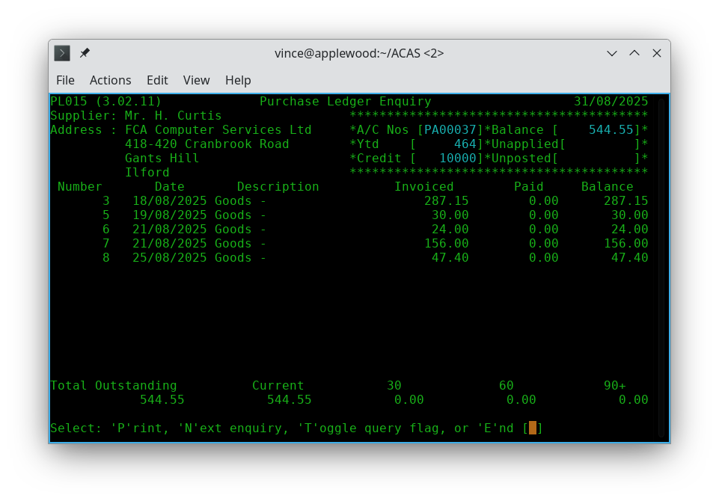

Figure 25.1 Online enquiry - pl015

Operations
Instructions by Program and Operation.

What follows is not by logic steps but only by program. For a logic flow see chapter 1.5, page 14.

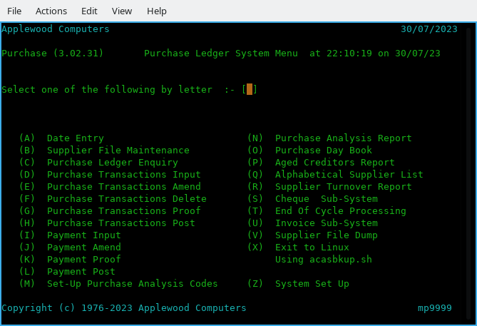
Figure 26.1 - Purchase System Menu

Option A - Date Input - PL000.
Enter or update today's date which will be used by default for all programs in the system but can be overridden as needed on a program by program basis.

Option B - Supplier File Maintenance (Data Entry) - PL010.
Options within are Enter, Amend,Delete, Print and Display a supplier.

Option C - Purchase Ledger Enquiry - PL015.
Provides a full status report for a supplier including all outstanding orders, un-applied payments, etc.

Option D - Purchase Transactions Input - PL020.
Enter a new order for a supplier.

Option E - Purchase Transactions Amend - PL030.
Amend a existing order for a supplier that has not been posted.

Option F - Purchase Transactions Delete PL040.
Delete a existing order for a supplier that has not been posted.

Option G - Purchase Transactions Proof PL050.
Run a proof report for all Transactions that have not been posted. This must be run prior to running Transaction Post - option H.

Option H - Purchase Transactions Post - PL060.
This includes a purchase transaction extract and analysis (PL055) which is hidden from view before running. the last step, transaction post PL060. These step must be preceded by running autogen post, if in use. This process will check if a proof has been run prior and issue an error message if not then return to menu.

Option I - Payment Input - PL080 - Manual Mode.
Enter a new payment against posted transactions.

Option J - Payment Amend - PL085.
Amend a existing payment against posted transactions.

Option K - Payment Proof - PL095.
Run a proof report for all payments that have not been posted. This must be run prior to running Payment Post - option L.

Option L - Payment Post - PL100.
Checks if a proof report has been run and if not issue, a error message and then aborts otherwise will post all payments in the batch file before returning to the menu..

Option M - Set-Up Purchase Analysis Codes - PL070.
On first use (including that for sales ledger), will create all default codes after which, you can add, amend or delete one or more analysis codes.

Option N - Purchase Analysis Report - PL130.
Will produce the report as requested.

Option O - Purchase Day Book - PL140.
Will produce the report as requested.

Option P - Aged Creditors Analysis - PL120.
Will produce the report as requested, it does not allow for an abort it must be run once started.

Option Q - Alphabetical Supplier List - PL160.
After entering any report criteria will produce the report. Pressing return for supplier number will use the default settings and this is the normal way to use this report.

Option R - Supplier Turnover Report - PL170.
After entering any report criteria if any, will produce the report. Pressing return for supplier number will use the default settings and this is the normal way to get this report.

Option S - Payment (semi automated) system - PL900
Produces a menu offering options which offers a new set of options, see figure 26.2.

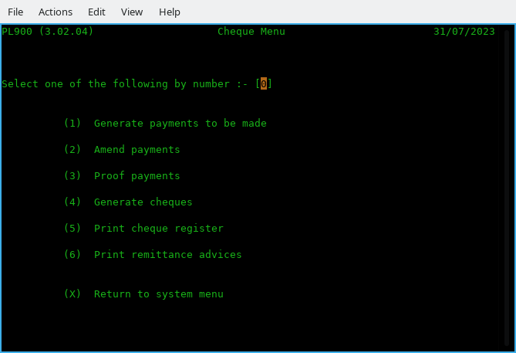

Figure 26.1 Payments Menu (Auto)

Option 1 - Generate payments to be made - PL910
See figure 26.2 and this has only one - Current age to pay on.
This is to restrict the ageing test for which to issue a payment so that younger one's are ignored. If days amount needs changing enter N to change it.

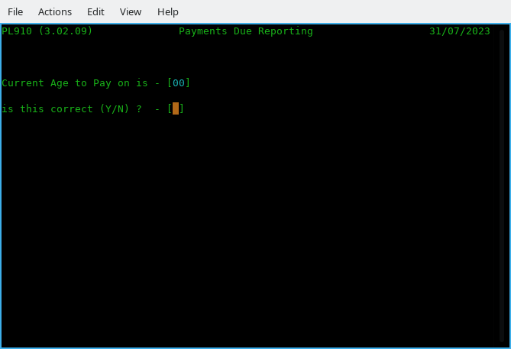

Figure 26.2 Payments due Reporting

Option 2 - Amend payments - PL920
Amend payments produced by option 1.

Option 3 - Proof payments - PL930
Produce a report showing payments due to be made. Can be used to create a banker payment report.

Option 4 - Generate Payments - PL940
Will convert proposed payments to actual.

Option 5 - Print Payment Register.
This program subject to any changes will produce cheques for payment or a list of B2B (BACS) scheduled payments to be given to your bankers. This program will need to be changed to match their requirements. [ B2B - Bank to Bank ].

Option 6 - Print Remittance Advices.
This program may need changes to match your requirements for these advise notes such as generate emails to each supplier, advices printed out for each supplier or any other variation that you require.

Option X - Return To System menu
Returns back to the main menu.

Option T - End of Cycle processing - XL150
Will ask for confirmation a back up has been run then after some checks offers to process Sales and then Purchase Ledgers updating previous quarters, and year to date total figures, etc. After this point, and if used, run the period reports for Stock control, IRS ledgers as needed,
Likewise for General if used, along with any other needed reports for end of period processes.

Option U - Transaction Sub-System - PL900
Offers two options via a new menu :

Option 1 - Amend Invoicing Fixed Data
This option opens a sub menu which offers a new set of options, see figure 26.3

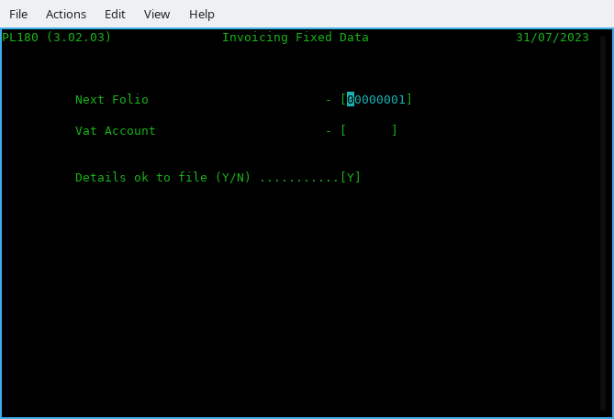

Figure 26.3 Folio Sub Menu

Next Folio - Changes the starting folio number from the default when first using ACAS of 1 to another of your choice - Make sure that you do not use any that may exist in the system currently. This number will be incremented by 1 for each order as you enter transactions and this number is the one to use for amend, delete changes, etc.

Vat Account - Set the VAT account to be used for Purchase Ledger using the IRS CoA (Chart of Accounts). This will, if set up on the parameter file will be given allowing it to be changed. this is not checked that it exists in IRS (or GL) so make sure it is.

Details OK to file (Y/N - To confirm that the provided answers are correct or not, in which case starts back to the first option.

9. Recurring Transaction Processing.
This feature has not been transferred over from sales ledger as :

1. It was not expected that any one would have a need for this option in purchase ledger.
2. No one has actually requested it at this point in time - in which case it will be made available but if requested :-
This will take a few weeks to code plus testing.
But in case it is added, here are the various aspects of it.
These processes then, can (but subject to change) offers the following options

Option 1 - Enter / Amend Recurring orders - PL810
This program allows user to enter, amend or delete an orders record based its the unique folio number and that of the supplier number. You should refer to the printed output from option 2, PL820.
See the display shown in figure mm, page yy. -> INSERT DURING BASIC TESTING.

Option 2 - Proof Recurring Orders - PL820
Provides a report showing all recurring orders in the system, providing date it is to next to be issued, frequency, repeat number and line item breakdowns and the order totals. These line items detail along with the amounts, etc. are taken from when the order was first entered and it is NOT updated again unless you run PL810 in Amend mode, so if there are pricing updates for these you will need to manually change in Amend mode.
Sample report to be added as figure mm, page yy >> INSERT DURING BASIC TESTING.

Option 3 - Post Recurring Orders - PL830
This process will first check if there are any autogen records at all and if not terminate, otherwise will examine all active recurring orders looking for any that have a date (that was entered or has been updated by this process), for any that matches today's date, plus or minus two days (as defined in the program source).
This allows the program to run before or after a holiday period or weekend - providing it is within this time period. The date normally used is the first day of the month and assuming that is the case, it will process orders providing the date run is 3rd, 2nd, 1st of this month, and last two days of the preceding month.
On finding a date that is within this test it will post the recurring order details to the batch purchase order file so that the normal transaction order proof and posting programs will pass them to the purchase open item file. Note that whenever posting programs are run the PL830 autogen / recurring order post program will run first, in case this program was not manually selected and run.

On finding a recurring order to post it will then update the date for the order to be next issued based on the frequency as set in (program PL810) Recurring Order Entry, saving the record for any later processing. If a entry has a repeat value not equal to zero or 99 it will subtract 1 from the count and when the count is zero the recurring record will be deleted as finished.

This should produce a report showing the activated transactions.

Option V - Supplier File Dump - PL190
Produces a largish listing for all suppliers in the system having asked for any reporting criteria that using return, will skip and report on all in landscape mode. Address lines include the delimiters. You would not normally want this report as was created for testing purposes but it is here just in case anyone has a need. It will show (see third supplier) outstanding balances, quarters 1 through 4, current purchase this month and payment data, etc. As you can see it is a long report as using the test data runs to 278 pages. See example based on test data used in system testing :

PL190 (3.02.06) Purchase Ledger Dump Page 1

Applewood Computers Report On : All 01/09/2025

Purch-Key PA00011 Purch-Credit 30.00 Purch-Current 0.00
Purch-Name Mr. K. Farmer Purch-Discount 40.00 Purch-Last 0.00
Purch-Addr1 Moldavia Ltd!418-420 Cranbrook Road!Gants Hill!I Purch-Notes 00 Turnover-Q1 0.00
Purch-Addr2 lford!Essex Purch-Average 0.00 Turnover-Q2 0.00
Purch-Phone 01554-6262 Purch-Limit 10000.00 Turnover-Q3 0.00
Purch-Fax Purch-Activety 0.00 Turnover-Q4 0.00
Purch-Status Live Purch-Last-Inv
Purch-Email Purch-Last-Pay
<-------------------------------------------------->

Purch-Key PA00029 Purch-Credit 30.00 Purch-Current 0.00
Purch-Name Mr. S. R. Colman Purch-Discount 40.00 Purch-Last 0.00
Purch-Addr1 Anco Computer Services Ltd!4 Benton Road!Ilford! Purch-Notes 00 Turnover-Q1 0.00
Purch-Addr2 Essex IG1 4AT Purch-Average 0.00 Turnover-Q2 0.00
Purch-Phone 01554-4164 Purch-Limit 10000.00 Turnover-Q3 0.00
Purch-Fax Purch-Activety 0.00 Turnover-Q4 0.00
Purch-Status Live Purch-Last-Inv
Purch-Email Purch-Last-Pay
<-------------------------------------------------->

Purch-Key PA00037 Purch-Credit 30.00 Purch-Current 544.55
Purch-Name Mr. H. Curtis Purch-Discount 40.00 Purch-Last 0.00
Purch-Addr1 FCA Computer Services Ltd!418-420 Cranbrook Road Purch-Notes 00 Turnover-Q1 464.50
Purch-Addr2 !Gants Hill!Ilford!Essex Purch-Average 92.00 Turnover-Q2 0.00
Purch-Phone 01518-0226 Purch-Limit 10000.00 Turnover-Q3 0.00
Purch-Fax Purch-Activety 5.00 Turnover-Q4 0.00
Purch-Status Live Purch-Last-Inv 25/08/2025
Purch-Email Purch-Last-Pay
<-------------------------------------------------->

- - - cut - - - then 277 pages later

PL190 (3.02.06) Purchase Ledger Dump Page 278

Applewood Computers Report On : All 01/09/2025

Purch-Key PP00655 Purch-Credit 30.00 Purch-Current 0.00
Purch-Name Mrs S. M Walton Purch-Discount 40.00 Purch-Last 0.00
Purch-Addr1 Castle Business Systems Ltd!ECL House!Park View Purch-Notes 00 Turnover-Q1 0.00
Purch-Addr2 Road!Berkhamstead!Hertfordshire HP4 3EY Purch-Average 0.00 Turnover-Q2 0.00
Purch-Phone 044277-4881 Purch-Limit 10000.00 Turnover-Q3 0.00
Purch-Fax Purch-Activety 0.00 Turnover-Q4 0.00
Purch-Status Live Purch-Last-Inv
Purch-Email Purch-Last-Pay
<-------------------------------------------------->

ACAS System wide File and RDBMS Table Usage Chart

The following chapters are to assist along with the ACAS system specific manuals full usage of the ACAS systems.

File # | File name | Table name  [ -rec ] | DAL (MT) | Isam? | GL | IRS | Sales | Purchase | Stock
00 | system | system  sysdeflt  sysfinal  systot | system  dflt  final  sys4 | Rel | rw | rw | rw | rw | rw
01 | glwork | n/a | n/a | ???
02 | archive | n/a | n/a | Seq | rw?
03 | final | n/a | n/a | Seq | rw | rw
04 | slautogen | slautogen | slautogen | IS |  |  | rw
05 | ledger | glledger | nominal | IS | rw
06 | posting | glposting | glposting | IS | rw |  | w | w
07 | batch | glbatch | glbatch | IS | rw |  | rw | rw
08 | postings2irs | psirspost | slposting | IS |  | rw | w | w | w
09 | tmp-stock | n/a | n/a | Seq |  |  |  |  | rw
10 | staudit | stockaudit | audit | IS |  |  |  |  | rw
11 | stockctl | stock | stock | IS 3i |  |  |  |  | rw
12 | salesled | saledger | sales | IS |  |  | rw
13 | value | valueanal | value | IS |  |  |  |  | rw
14 | delivery | delivery-record??? | delivery | IS |  |  | rw
15 | analysis | analysis | anal | IS |  |  | rw? | rw? | rw?
16 | invoice | sainvoice  sainv-lines | sainvoice | IS |  |  | rw
17 | delinvno | sadelinv | sadelinvnos | IS |  |  | rw
18 | openitm2 | n/a | n/a | Seq |  |  | rw
19 | openitm3 | saitm3 | otm3 | IS |  |  | rw
20 | oisort | n/a | n/a | Seq
21 | Work.tmp | n/a | n/a | Seq | rw
22 | purchled | puledger | purch | IS |  |  |  | rw | r
23 | delfolio | pudelinv?? | delfolio | IS
26 | pinvoice | puinvoice  puinv-lines | pinvoice | IS |  |  |  | rw
27 | poisort | n/a | n/a | Seq |  |  |  | rw
28 | openitm4 | n/a | n/a | Seq |  |  |  | rw
29 | openitm5 | puitm5 | otm5 | IS |  |  |  | rw
30 | plautogen | plautogen | plautogen | IS |  |  |  | rw
31 | bostkitm |  |  | Seq |  |  | rw |  | rw
32 | pay | plpay | payments | IS |  |  |  | rw
33 | check | n/a | n/a | Seq |  |  |  | rw
34 | irsacnts | irsnl | irsnominal | IS |  | rw
35 | irsdflt | irsdflt | irsdflt | IS |  | rw
36 | irspost | irsposting | irsposting | IS |  | rw
37 | irsfinal | irsfinal | irsfinal | IS |  | rw
38 | postsort | n/a | n/a | Seq |  | rw
## | Various temp names | n/a | n/a | Seq | rw
ACAS File usage Table

rw = Read/Write IS = Indexed sequential
r = Read only IS 3i = Indexed Sequential but with 3 keys
w = Write only Seq = Sequential
Rel = Relative
n/a = Not Applicable – Cobol file only.

Unless otherwise indicated all files have an extension of “.dat”
## Other files exist during General Ledger running but all with extension “,tmp”
## The other systems use temp file ending .dat and are not deleted others with .wrk are deleted at end.
All temporary files are stored in current directory usually as pointed to by environment variable
ACAS-LEDGERS set up by the install-acas.sh script. The script install-ACAS-preinstalled.sh does not do this as it is previously done by the former script install-acas-sh.
All temporary files tend to be small but not greater in size than any primary files.
All RDBMS table names end with ‘-REC’ and are ALL upper-case.
All DAL programs names end in MT but not shown above.
ALL Cobol → table loader programs have same name as DAL but ends in LD..
ALL FH programs take their name using File number (#) e.g., file 32 FH is acas032.
IRS is slightly different, these are named acasirsub1, 3, 4 and 5 that replaced the old FH called sub1, 3, 4 & 5.

The invoice tables have secondary tables that are directly linked but not listed above.

Migration to other RDBMS systems will use same names but stored in another sub directory under DAL within common which already has MySQL DALs in MySQL. Copied from the common directory.

The FH (File Handlers) in both common and FH are consistent regardless of RDBMS used.

Individual file details where needed.
This chapter is mostly useful to programmers or anyone else with a wish to understand the underlying structure of elements of the ACAS system that may be non standard etc.

ACAS System file
This file consists of four unique records:
1. ACAS parameter record containing details for the set up of the entire ACAS system.
2. Defaults record for GL (IRS has its own file).
3. Final account heading replacements for GL.
4. Sales and Purchase period totals.

Stored as relative values 1 through 4.
This is the only file that uses relative (absolute addressed) keys.

The following is for ACAS v3.02 and later.

All others use ISAM (Indexed keys for Sequential Access Method) and this is to match up with the storage methods used within DB's (Databases) such as mysql, mariadb, Postgres, DB/2, Oracle and even ODBC.

ODBC is a common standard that can process for all Databases but is slower to access and even more, so for a busy environment such as on the DB server where many are accessing the system but it will have a of of time setting up any other DB's.

Record formats for all - Cobol files and DB tables are generally exactly the same but where there are differences, the database records are transferred in the same layout and format, as that for the Cobol file records. In some cases more than one table has to be accessed to obtain the data required for one Cobol file record and these issues are handled within each DB DAL handler without the FH.(File Handler) being non the wiser at they just get the record as known in the file record only.

There is one FH for each Cobol file and there is one DAL for each table that related directly with the corresponding DB table for each FH.

To support another database other than Mysql and Mariadb, new DAL's have to be created for each table per DB and this means that to support a new DB a new set of DAL's (Data Access Layer) has to be created / written where the first two (one for the system parameter file) and the other for the first selected normal data files and this acts as the default module that all the other can be coded from. The System parameter file is the odd one out that it is a special case in processing, that does not match up with the way that all the other Cobol files used within the ACAS system are processed.

These two are the hardest or take the most time to program, but all the others can be created from the second one - the first of the normal data files once finished and tested.

This helps to keep the process as easy and simple as possible to develop for each new database. - Well that's the theory.

The record layout for all files can be seen via the source files for all the programs as included files and these can be found in the directory copybooks.

These copy books are broken down by the type and location of where they are copied from within each program such as for the SELxxxx, (select section in file-control), FD (file definition) area in file section, WSxxxxx in working-storage for the working areas used while a program is running.

Easy to spot in a program source file as they start a line with :
copy "filename.cpy".

All such copybooks have the extension of .cpy after the filename to distinguish then from the Cobol programs which have the extension of .cbl or if they contain DB SQL code the extension is .sbl and these sources are passed through a pre-compiler which create a .cbl file that is in turn used by the Cobol compiler. The SQL pre-compiler converts the SQL type statements into Cobol which is understood by the Cobol compiler as it can not understand SQL.

For example regular SQL code such as EXEC SQL READ would generate some lines of code for the compiler that can then be processed.

Reporting problems with ACAS products

Use the bug reporting function on the ACAS sourceforge website for both problems in the software and in any supplied manual. Do not forget to specify the name & version of the program with the problem, also specify the level of the issues such as : -

Priority
Level Title Description

1. Critical Cannot run a previously working ACAS system.
2. Urgent Can run the system but cannot work with some functions.
3. Partial A function is not working as described in manual.
4. Function Needs additional functionality.
5. Cosmetic A minor problem such as in screen display layout or colours used
or the way data is entered.
6. Undefined Low priority issue not within other levels.

Commercial users should also prefix priority number with a ‘C’.
Level 1 is same day / 4 hours. [with prefix C otherwise 24 hours, where possible].
Level 2 is same day / 12 hours. [with prefix C otherwise 72 hours, where possible].
Level 3 & 4 is 3 days. [with prefix C otherwise, as time permits].
Level 5 & 6 is as time permits. [with prefix C, as time permits].

E & OE Applies.
The above timings is on a best effort basis only as holidays etc., can interfere with these.

Commercial users with active maintenance contracts, can also use the direct website as outlined in the supplied support documentation and the email address mentioned below for problem reporting.

If it is critical or urgent you can also send an email, see address on inside cover but still use the bug reporting system so other users can see that it has been reported.

Remember if it is not reported – It cannot be fixed and do not assume that some one else has reported it. Check the bug lists to see.

If in doubt issue a bug report. if warranted, retain a copy of all data files in case they need to be sent in (but only after archiving them with zip, rar or tar with a file name indicating the supplier / user) i.e., applewood-bug-report-1.zip. Remember to include a copy of any relevant reports that could help by scanning them in using a scanner or 3 in 1 printer saved by a pdf file or failing that one or more jpg files.

Subject to the type of problem, you may be asked to send these in for inspection. After the problem has been located and resolved, these files will be deleted here and after being advised of this you can delete such files / archive.

Error messages used within the ACAS system

Here is a list by system and program of all messages that signify an error or warning that can appear.
However there are warning messages that can appear during data entry that are not listed.

Cobol and C Error Messages

Applewood Computers software is designed to trap almost all errors which can arise under normal circumstances, but due to language limitations and/or hardware problems, some errors may occur which the programs themselves cannot handle. These errors are Cobol or C errors – see File Access Error numbers page 96 You should look at the Cobol compiler documentation for more information as these can change between versions of both the Cobol compiler as well as the GCC C compiler. Also see RDBMS error codes and MySQL SQL Status messages on page 97 for additional RDBMS status values that can also be displayed.

Some of these can signify problems with lack of free storage space on your hard drive, a hard issue with it or you are running in the wrong directory in which case check your environment variables for the settings of ACAS_BIN for the programs and more importantly the environment variable ACAS_LEDGERS for your data.
This you can find in konsole or other terminal program by typing : set | grep ACAS_LEDGERS and this will result in a text similar to : ACAS_LEDGERS=/home/yourusername/ACAS

This applies even if you are running using RDBMS as the system parameter file is required to be a Cobol file at start up and located in this directory. An temporary override for this setting can be done when ever running any of the system programs i.e., ACAS, irs, general, sales, purchase or stock by adding to the system name the string ACAS_LEDGERS=a new path such as :
Purchase ACAS_LEDGERS=/home/username/temporary-directory

ACAS Error Messages

Messages that instruct you to contact your Supplier or IT support generally indicate an error condition that should not arise under normal circumstances, such as no free disk space. Ensure that the hard drive you are using has loads of free space such as over 1 GB and with the risk of fragmentation of data per file, it is always wise to make it more. Here more so in Windows based systems but can apply to *nix based one’s as well.

References to ACAS support usually mean a possible programming error that over the years has not ever appeared but with a changed Cobol compiler (GnuCOBOL) and the usage of RDBMS, anything is possible.

Program names herein are shown in upper case for ease of reading but are actually stored and used within the ACAS system using lower case letters other than the optional master menu program ACAS.

SSDs and Garbage Collection.
If you are running with SSD’s you should be aware of the problem of garbage collection on *nix based systems such as Linux. This relates to the fact that all SSD’s are not created equal, e.g., some have good controllers built-in and other – well not really.

An example, when we first installed SSD into Linux based systems we found out very quickly that you had to run a Linux utility called fstrim on a regular basis like in nightly so we set up a cron job to do just that at midnight, running as sudo (or root) ‘fstrim -av’.
Great you think, well not so much when running Crucial SSDs as their controller require 8+ hours of idle to process the garbage and even then may be not, as it forced us to shutdown the system and boot into bios and leave it – No, not a solution as the SSD filled up very quickly and I do mean quickly and I cannot spare the system time to make it offline. This is not the only brand that will cause this problem.

So SSD mk 2 – bought Samsung 850 as a test and found out that their controller did not require such idle time. Then bought two m.2 960’s SSD’s and installed in server and laptop (windows) an Samsung 850 into a Mac Pro dual quad Xeon CPU system and all work as advertised well apart from a media system that also has a m.2 that in some circumstances such as transferring lots of video media and yes I mean a lot – like 40 GB. As the SSD is the system partition all data coming in, goes to that first before being moved to the required location and that is with copying to the specific hard drive as the SSD is used as some temporary data areas although not sure why or where exactly.
So in this instance it cannot do a clear up quickly enough to cope, again do not know why. Just have to remember not to do a lot at a time :(

So what is this about I hear you ask? Well unlike a normal hard drive that, when you delete a file it is job done. It is not that straight forward for a SSD. When a file is deleted or moved or updated it has sectors / clusters on the media that are no longer in use and the SSD controller has to go through a process called Garbage Collection and this mean the on-board SSD controller goes though each sector checking if it is not in use then clear the whole sector down by setting it to X‘00000000’ (X = Hex) for every byte in the sector, so takes a wee bit of time.

Now under Linux as we run the fstrim process every midnight it keep it under control at least on the servers and Mac pro. The Windows system seems to cope without doing a thing – just as well really as I have no idea what it does as I cannot find any docs on it.

So long story very short if you run SSD’s on a Linux based system you MUST make sure fstrim is run often enough to clean it up before it gets out of space that has not been cleaned up because regardless of its size, if all clusters have been used and have not been cleaned up it is the equivalent of a filled drive, regardless of size and we are using 256GB and 500GB despite them only used for booting and minor other data requirements, they can and do get clogged up.
If you have rebooted a *nix based system such as Linux, Apple's OSX etc. the next time you run fstrim -av you will get a large figure and this is because the reference held is lost on a reboot so you can ignore it the first time. If needed although should not be needed, run fstrim twice per day say midnight and noon if system running 24/7.

So for *nix users, you have been warned. So keep that in mind when looking at some of these ACAS error messages regarding a full drive. I recommend you do NOT use a SSD to hold application data on and their performance is not that heavy a usage problem as most of the time most of ACAS is waiting for the user to key some thing in and the grunt work is done quickly enough even if you have say 25,000 records for each file and we are running in production over 1,000 for both purchase and sales ledgers and can (for clients) be creating 1,000+ invoices/receipts per day and over Xmas it was closer to 5,000 per day. Kept the pickers and packers very busy.

Some of these transactions came through their online shop that is linked into Purchase Ledger with a bespoke program to transfer the data over every so many minutes or on every transaction. The web shop also accessed the stock control system to check for stock quantity etc. On of the benefits of ACAS using special modules to handles file processing i.e., FH (File Handlers) and for rdb databases DAL (Data Access Layer) that are called by the FH if needed. These can also be used by other software such as online web shops to access the stock system and pass on order details to create an invoice or receipt for printing subject to stock availability.

One of the benefits of running a batching system where all invoices go to one printer, picking or packing lists go to another (in the warehouse) may be both using continuous stationary and statements to a third (laser) when needed. The laser printer has an overlay feature that holds the graphics for a header page so that ACAS output just prints out in the correct locations on the page while the overlay also produces the titles, company details etc. at the same time. This option may well also be available on some ink-jet type printers including Ink-tank.

It should be pointed out that some clients of ACAS used both matrix and line printers as well as laser printers to push things through with auto folding and enveloping equipment where needed.

Just depend on the size of the business and volume of sales per day but the benefit is that using ACAS you can start very small, and as you grow can upgrade your computer equipment and printers to handle the volume.

Purchase Ledger Error Messages

This section contains the full text of all the error messages issued by the Purchase Ledger system.
PL system errors are in the form:

PLnnn message

The "PL" indicates an PL system error. The "nnn" is a three digit number unique to this message. The "message" is a descriptive phrase explaining the problem. This appendix gives more in-depth descriptions of the errors and gives possible solutions.

Each PL programs has a unique range of error message numbers as shown in Figure B.1. Some error messages are common to all or many programs in the ACAS system and these start with SY, or AC for any FH (File Handler) and SM for any DAL (Data access Layer – rdbms processing). They all have numbers ranging from "000" to "999".

Some error messages should never occur. If they do, it is usually an indication of some more serious problem with the hardware or operating environment. Such messages will ask you to contact your IT or ACAS support. Before doing so, back up all data then restore from last known point of good data and rerun the programs, noting all actions taken. This will help to determine the problem.

ACAS System wide Messages
These apply to all system programs, ACAS, IRS, General, sales, purchase, Stock etc.

Messages produced throughout ACAS are prefixed by a two letter code that indicates what program produced them and the program could be called from another system, e.g., PL070 and PL070 can be called by Stock, Purchase or Purchase to set up the Analysis file. The system parameter set up program can be called by any of the systems to set up or amend it.
There are other instances of this type of processing that can occur.
Messaging prefixes are :

IR = IRS
GL = General Ledger
PL = Purchase Ledger.
SL = Sales Ledger
ST = Stock Control
SY = System set up programs or programs and system wide messages.
SM = DAL’s (Data Access Layer) for RDBMS processing.
AC = FH’s common system wide messages.

From initial start up in all system programs.
SY005 Invalid Date: Formats are dd/mm/ccyy, mm/dd/ccyy or ccyy/mm/dd
only. i.e., 1/1/2011 it should be 01/01/2011.
SY006 Program Arguments limited to a maximum of two and you have specified n
As indicated, the only values currently accepted is :
ACAS_LEDGERS=path-to-data-directory.
SY007 Program arguments incorrect:
You have specified parameters to a system program
that are wrong. Correct and rerun.
The only values currently accepted is :
ACAS_LEDGERS=path-to-data-directory.
SY008 Note message & Hit return
As indicated see the other preceding message.
SY009 Environment variables not yet set up : ABORTING
Working directory environment variable not set up, fix
and rerun. Is this a new user ?
This should have been done by the ACAS setup up
process : install-ACAS.sh if so, run it for user.
SY011 Error on systemMT processing, Fs-reply = nn
Got an error when writing to the RBD for the first time
nn = return value but could have a preceding msg.
Could mean that the RDB is not running or set up
correctly. If not report to ACAS software support.

From System parameter set up program (SYS002) callable by all system programs.
SY101 Open I-O Err = nn: Contact IT support and provide nn*. Should not occur.
SY102 Read Err 1 = nn: Contact IT support and provide nn*. Should not occur.
SY103 Rewrite Err 1 = nn: Contact IT support and provide nn*. Should not occur.
SY104 Fix and Press Enter: See previous message.
SY105 Lines > 28 Print lines must be greater than 28
SY106 Error on systemMT processing
} See other info for more details, SY011 it is the same).
SY107 Error on dfltMT processing
} and provide the nn* reference as well to
SY108 Error on sys4MT processing
} IT support. Again also see SY011.
SY109 Error on finalMT processing
} These should not occur but might indicate lack of
} space on your hard drive.
SY110 Rerun Parameter Set up?
Enter Y or N.
SY111 Print Spool Name must be defined
You MUST define these spool names otherwise there
will be no printed output produced. Names taken from
the CUPS system. Use URL http://localhost:631 to locate.

SY902 Program Error: Temp rec = yyy < System-Rec = zzz
This means that the record layout size is wrong in the respective FH (File Handler).
This and other XX902 – 90n is similar but for other records. XX=IR,GL,PL, PL, ST. (Listed later.)

yyy = size of temp record in bytes.
zzz = size of file record. In bytes.

This requires that the source code of the relevant program needs to be changed and re-compiled before using the system.
Report this problem to ACAS support as it is a Critical Programming Error.
Needless to say it should not happen unless you have an old copy of the ACAS sources or more likely, have mixed old and new versions together.

Commercial versions only: -- As this option has been discontinued it should never happen.
SY044 The system has detected an unauthorised change of user name.
SY045 Contact your Supplier or System Admin
Internal company name is not the same as in the parameter
file. Check what directory you are running from or have you
copied the system.dat file from another company. You can
not continue with ACAS.
Report to your IT team or ACAS Support.

From FH (the Cobol File Handlers)
AC901 Note error and hit return As indicated see the other preceding message.

From DAL (the RDBMS Data Access Layer)
SM901 Note error and hit return As indicated see the other preceding message.
SM004 SQL Err No.= xxxx Serious programming error or mysql server not online,
See specifics following text msg.

From FH-and DAL Logger (During Testing only)
FH901 Note error and hit return As indicated see the other preceding message/s.
FH903 Write failure on Log File = nn
No disk space available. Create more free space
greater than 256 MB. Other error message can appear.
Also see File Access Error numbers on page 96
SM901 Note error and hit return As indicated see the other preceding message/s.

ACAS – The top level master program who’s usage is totally optional.
None.

System wide Messages for Purchase
PL002 Note error and hit return As specified.
PL004 Now Hit return As specified.
PL005 Invalid Date As specified, format is wrong, re-enter. Options are as per
the setting you made in the parameter file : -
UK - dd/mm/ccyy, US - mm/dd/ccyy or Intl - ccyy/mm/dd

System wide Purchase FH ~(File Handlers)
Common
PL901 Note error and hit return As indicated.

acas022 FH for the Purchase Ledger File
PL902 Program Error: Temp rec = yyy < Invoice-Rec = zzz
PL903 Here it can be one of four Purchase files and indicates that
PL904 the size of the temporary record is less than the actual file
record size.
PL905 The file can be Purchase Ledger, Invoice, DelInvNo, OTM3
This means that the record layout size is wrong in the respective FH (File Handler) and these respectively are acas012, acas008, acas016, acas017, acas019.

yyy = size of temp record in bytes.
zzz = size of file record. In bytes.

This requires that the source code of the relevant program needs to be changed and re-compiled before using the system.
Report this problem to ACAS support as it is a Critical Programming Error.
Needless to say it should not happen unless you have an old copy of the ACAS sources.

acas026 FH for the Purchase order Invoice File
PL905 See PL902 for information.

acas017 FH for the Purchase DelInvNo
PL903 See PL902 for information.

acas029 FH for the ITM5 File
PL904 See PL902 for information.

System wide Purchase DAL (the RDBMS Data Access Layer)
None. See specifics following text msg.

Specific Purchase Messages by Program or program
Main menu (Purchase)
None.

Start Of Day (PL000)
None.

Supplier File Maintenance (PL010)
PL101 Addr Err Error, missing too many or incorrect delimiter ?
PL102 Supplier Record Not Found As indicated. Use the correct account number.
PL103 Purchase Ledger files have not been set up yet
Information, see next message.
PL104 Do you wish to create them (Y/N) ? [ ]
With previous message – create files ? Do so.
PL105 Creating Purchase & Delivery Files
Information.
PL106 Opening Purchase file gives Error when opening/creating file, no space on HD ?
PL107 Opening Delivery file gives Error when opening/creating file, no space on HD ?
PL108 Abort Or Recover (A/R) : [ ] Respond A or R.
PL109 <<<Can not Delete currently active account>>>
As Indicated. There are transactions present.
PL110 Supplier Record Already Exists
As indicated. Did you enter the correct number ?

Purchase Ledger Enquiry (PL015)
PL111 Error On Writing Work File. Hit Return To Abort
No disk space ?
PL112 Can't open file After close so is a programming issue, advise
ACAS support as it should not happen.
PL113 Can't find it Cannot find account or Order.
PL114 Record not found Cannot find requested account or Order.
PL115 Error On Rewrite Abnormal error when trying to update record.
PL116 Note: and hit return to continue As indicated.
PL117 No Work File Created..No Data As indicated.
PL118 Work file Created Information.
PL119 Only on invoices Action not valid for record type : Invoice.
PL120 Purchase Transactions Not Posted
Post all transactions before re-running program.
You might need to do the same for payments.

Transaction Entry (PL020)
PL180 Err on Folio Rec. write : Followed by other messages indicating exactly the
problem. You will need to re enter this transaction
after fixing the issue but likely to be out of disk space.
PL181 Folio To Credit Does Not Exist On ITM5
The PO you wish to credit cannot be found on open
item file. Possibly you deleted it pre posting.
PL182 Folio To Credit Is Paid As specified - it has already been paid.
PL183 Folio To Credit Has Query Flag Set
You might want to check why before continuing.
PL184 You Can Only Credit Invoices. Not Receipts, Credit Notes
As specified.
PL185 Credit of Prompt Pay/Late Charge will be Automatic
As specified.
PL190 You can only credit a Folio with the same account number
As specified.
PL191 P.A. File Does Not Exist At this point it should but if not, create using menu
option M.

PL192 P.A. Code Does Not Exist You have select an PA code that cannot be found, did
you specify the right one, if so you will need to create
it via menu option M.
PL193 No such Supplier As specified.

Supplier Creation For Order Entry (PL025) - [ via PL020 ]
PL131 Supplier Record Already Exists As specified - that account already exists.

Transaction Amend (PL030)
PL180 Err on Folio Rec. write : Followed by other messages indicating exactly the
problem. You will need to re enter this transaction
after fixing the issue but likely to be out of disk space.
PL181 Folio To Credit Does Not Exist On ITM5
The PO you wish to credit cannot be found on open
item file. Possibly you deleted it pre posting.
PL182 Folio To Credit Is Paid As specified - it has already been paid or credited.
PL183 Folio To Credit Has Query Flag Set
You might want to check why before continuing or
Reset this flag.
PL184 You Can Only Credit Invoices. Not Receipts, Credit Notes
As specified.
PL186 Err on Folio Rec. Rewrite : Error - possibly out of disc space. check and fix
before you continue. You may need to redo this
amendment.
PL187 Folio Not Found!!!! As specified.
PL188 Folio Already Passed To Purchase Ledger!
You cannot amend this transaction may be issue a
credit / debit note.
PL190 You can only credit a Folio with the same account number
As specified.
PL191 P.A. File Does Not Exist At this point it should but if not, create using menu
option M.
PL192 P.A. Code Does Not Exist You have select an PA code that cannot be found, did
you specify the right one, if so you will need to create
it via menu option M.

Transaction Delete (PL040)
PL187 Folio Not Found !!. As specified transaction not found
PL188 Invoice Details Already Passed To Purchase Ledger!
As specified. Cannot be deleted. If needed, create a
credit note.

Transaction Proof Report (PL050)
PL120 No Transactions to proof! ...Press return for menu.
As indicated.

Transaction Proof Report Extract (PL055)
PL201 Analyst records with desc, 'Emergency Name' created
As shown - you will need to change the descriptions
With the correct one via menu option M, Amend.
PL202 You will need to update these As above for PL201.
PL203 P.A. File Does Not Exist You need to set up Post Analysis records Option L.
PL204 Error writing to Open Item 4 File Out of free disk space ?

Transaction Posting (PL060)
PL130 Error writing Open Item 5 Record
Error when writing to OTM3 – No free disk space ?
See following messages for error number providing
error type. [see for File 11.3 or for table 11.4]
PL131 PE - CR SWOP: Return to continue
Zero value credit note – should not happen, report
to ACAS support with CR details.
PL132 Err on Batch file write : Error when writing to Batch record, No free disk
space ? See following messages for error number
providing error type. [see for File 11.3 or for table11.4]
PL133 Warning Record/s missing in Purchase File
Record from Ledger not present – Removed in error ?
Add record back via Supplier maintenance.
PL133T Warning Record/s missing in Purchase Table
Same as previous but for RDB database table.
PL133 should never happen also report to support.

Product Analysis Maintenance (PL070)
PL008 P.A. Code Already Exists As indicated, PA code already exists, use or select
another.
PL009 P.A. Group Code Does Not Exist
As indicated, you need to create it.
PL010 P.A. Group Code Used As Analysis Code
Add a detail PA record.
PL011 P.A. Code Does Not Exist As indicated, add record.
PLA12 Error on AnalMT processing Error on writing record, no disk space ?
PLA13 Hit return for Menu As indicated.
PLA14 Error on ValueMT processing Error on writing record, no disk space ?

Payment Data Entry (Manual mode) (PL080)
PL116 Note: and hit return to continue As indicated.
PL119 Purchase Transactions Not Posted
As indicated, There is no OTM (Open Item)
records, You need to post them first.
PL121 Transactions Not Posted; Payment Entry Not Allowed
As indicated, you need to post them first.
PL122 Batch Closed........Full! As indicated, proof and post before processing new
purchase orders transactions.

Payment Data Amend (PL085)
PL140 Not Yet Supporting Corrections As indicated but you can clear the exact paid amount.
using the exact paid amount. Then enter the correct
amount through payment entry.
PL141 Amount Approp Or Deduct Amt Not Zero
You have not allocated one or both values, fix it.
PL142 No Payments To Correct/Proof/Post
As indicated.

Payment Proof Sort (PL090)
PL142 No Payments To Correct/Proof/Post
As indicated.
PL143 System Error - OTM5 and OTMS not the same – xxx & Sorted – yyy
The records for the two are not the same size.
This is a programming error. Did you use the
wrong ACAS sources. Report the issue to ACAS
support. Do not attempt to continue. Critical error.
This should never happen.

Payment Proof Report (PL095)
None.

Payment Posting (PL100)
PL132 Err on Batch file write : Error when writing to the Batch record, No free disk
space ? See following messages for error number
providing error type. [see for File 11.3 or for table
11.4] with further details
PL137 Payments Not Proofed You must run payment proof first to check your input.

Trail Balance Sort (PL115)
PL151 Purchase Transactions Not Posted
There has been NO purchase orders posted.

Aged Creditors Analysis (PL120)
PL151 Purchase Transactions Not Posted
As specified, you need to run proof and posting first.
PL152 Payments Proofed Not Posted
As specified, you need to run the proof and posting
processes first.
PL153 No Open transaction records present
As specified – There is no PO transactions to report
on, you need to create some first.

Product Analysis Report (PL130)
PL160 Error reading value records - Examine the actual report error - possible corrupted
data file or table.

PL161 No data, nothing to do – exiting
No data exists yet.

Day Book Report (PL140)
PL161 No data, nothing to do – exiting
No data exists yet.

Ledger Database Alpha List (PL160)
PL005 Invalid Date You entered an invalid date, try again.
PL170 Not Found - Requested record/s not found.

Ledger Alpha Sort (PL165)
None.

Ledger Turnover Report (PL170)
PL005 Invalid Date You entered an invalid date, try again.

Transaction Menu & Fixed Data (PL180)
None.

Ledger Supplier File Dump (PL190)
None.

Recurring Order Processing (PL800)
None. Program not written / completed
Awaiting interest or requests from users as not
suspected it is needed.

Payments (Generate) menu (PL900)
None.

Payments Due Generation (PL910)
PL901 PE 910-01 LOGIC: Note and hit return
Amount less than zero - Program bug, please report
this as it should not be happening. Stops processing
for this transaction (on the OTM5 file).
PL902 Purchase Ledger not Found As specified. Are you in the wrong folder or have
deleted files or have had a system or HDD crash?
PL903 Purchase OTM file not Found As specified. Are you in the wrong folder ? & see 902.
PL904 Payment file Error on Open Cannot create a new file - out of disk space ?

Payments Due Amendments (PL920)
None.

Payments Due Proof (PL930)
None.

Cheque / Payment Writer (PL940)
PL902 Missing data In ledger file. Are you in the correct folder ?
PL903 No data to process. Hit return Cannot find the payments file.

B2B / Cheque Register (PL950)
PL132 Err on Batch file write : Failure on writing a record - out of disk space ?
PL904 PE 950-01 Logic: Hit return to continue
Record type not invoice found - system issue but
should never happen - report it to ACAS technical
support and retain all files and check your HDD for
errors.
PL905 PE 950-02 Logic: Hit return to continue
Cannot find key records that should be present.
Check your HDD for errors and if good report to
ACAS or your IT support.

Remittance advice Report (PL960)
None.

File Access Error numbers
02 Creating a Duplicate key on alternative key which allows duplicate keys.
04 Success (but incomplete)
05 Success (Optional File Not Found)
06 Multiple records (in LS)
07 Success (No Unit)
09 LS Bad Data
10 End of file reached if reading forward or beginning-of-file reached if reading backward
14 Out of key range
21 Key invalid
22 Duplicate key condition when duplicate keys are not permitted,
23 Start/Read has been attempted on an optional input file that is not present.
24 Key boundary violation
30 Permanent I/O error
31 Inconsistent file name
34 Boundary violation
35 File not found
37 Permission denied
38 Closed with lock
39 Conflicting attribute
41 Open has been attempted on an already open file.
42 Close has been attempted on an already closed file.
43 Read not done
44 Record overflow
46 Read error
47 "OPEN INPUT" denied (insufficient permissions to read file)
48 "OPEN OUTPUT" denied (insufficient permissions to write to file)
49 "OPEN I-O" denied (insufficient permissions to read and/or write file)
51 Record locked
52 End of page
57 "LINAGE" specifications invalid
61 File sharing failure
71 Bad Character
91 Feature not available

Note: There may be others but most if not all are here, see GnuCOBOL Documentation. Most if not all of these indicate a program error and you should report such, giving as much information as possible as to what you were doing at the time in an email to your IT department or the support email address as shown on inside front page.

Please always remember to provide the software version and name of the program or program that was being run that created or produced the error. Also the platform you are running on such as the operating system and hardware if not Intel or AMD X64 CPU.

The version details take the form of aannn v3.nn.bbbb where (in order)
aa = st = Stock, sl = Sales, pl = Purchase, irs = IRS, gl = General.
nnn = A three digit number from 000 to 999 indicating the program / program name.
nn = sub version of the software.
bbbb = Build number of the specific program .

RDBMS error codes
Here is the more common errors but there are a lot more see the RDBMS Error messages in the Mysql systems manual.

MySQL SQL Status messages

This is a small selection of what could occur for others see the Mysql SQL error documentation.
ACAS tries to rely on these more than on errno (Error numbers) below.

Sql-State 00000 = Operation completed successfully
01 = Completed successfully
0200n = No data found one way or another
[fs-reply/we-error] = Get random = 23 else = 10].
23000 = Dup primary key on insert same as fs-reply = 22.
Internal Errors :
99NKS = Invalid key # used.
99NKU = No valid key used.
99NKD = No valid key used for delete
99RNP = Read next with no position (no start 1st)
99GNS = Could not generate a start.

MySQL errno (Error numbers) that can possibly appear via ACAS.
There are many others see Mysql error documentation.

Error Recovery

Many of the error messages in section “System wide Messages” that relate to missing files can be attributed to only a few reasons:

- You are on the wrong directory before running ACAS, check which one is set in the environment setting for ACAS_LEDGERS= such as /home/username/ACAS.
You can find this in a terminal by running -
set | grep ACAS
this should produce something like this :
ACAS_BIN=/home/username/bin
ACAS_LEDGERS=/home/username/ACAS

So here you should be in the /home/username/ACAS

- The system is corrupted due to a power failure and you are not running your computer on a UPS (uninterruptable Power Supply). It is seriously advisable to run all business critical computer system on UPS’s and here we use units of 1000w or larger depending on the need to keep running times but the 1000w is good enough to finish off current data entry record and then shut down ACAS and then the system before the UPS software (apcupsd) does it. If no other reason then they give smooth power to the equipment at all times.

- Files have been deleted in error, you may have to recover from the last back up. These sit in a directory in the ACAS directory called temp-backups. Be careful before running a recovery procedure for example make sure you do a backup of the contents of the directory first, just in case.
Here is a perfect reason to make a copy of the backups produced by ACAS onto a USB memory stick or hard drive that you only connect prior to doing so, say daily etc. Create a back up strategy for your company if one does not yet exist and stick to it like glue. Remember to test the recovery of a backup in a temporary directory say '/home/username/ACAS/test-a' just for the purpose and test by running ACAS. For this to work you will need to pass the ACAS directory parameter when loading a ACAS sub-system e.g., for Purchase you would run
'Purchase ACAS_LEDGERS=/home/username/ACAS/test-a'.

WARNING: If you forget to do this, you will be using the data from the standard directory as set up by the install scripts, e.g., /home/username/ACAS.

If running a RDBMS based system ensure you have set up back ups for it, at least for the ACAS database which by default is called ACASDB but you can change it to anything having made sure it is the same one set up in the ACAS system parameter file. You should do it for all of your databases along with the rdbms system databases, so just back up the lot on a regular basis.

Scripts

The system uses a lot of these during the build / compile phase (see the manual ACAS – Building the ACAS system, chapter 5) but also a few during usage and most if not all, are for back ups. These sit in the ~/bin directory along with files that end with .sh for *nix operating systems. This is created using the install scripts install-ACAS.sh and install-ACAS-preinstalled.sh for *nix (such as Linux) users.

You might want to look at these and consider if you need to change them for local requirements.
Make sure you test them by running manually when in the ACAS directory. If you run under windows you will need to create batch command scripts that do the same.
See scripts listed here :

acasbkup.sh

#!/bin/bash
# *** backup script for ACAS v3 GC versions ***
# WARNING: this scripts filename 'acasbkup.sh' is fixed inside the ACAS menus
# Don't change it unless you know what you are doing but you can change the
# script content if you wish to use another folder or drive etc.
#
#
# 09/04/2009 vbc - temp backup dir and filename prefix change
#
if [ ! -d temp-backups ]; then
mkdir `pwd`"/temp-backups"
#temp-backups
fi

#cd temp-backups

tar cvfz `pwd`"/temp-backups/acas-bkup-"`date +%Y%m%d%H%M%S`.tar.gz *.dat
#
# place here commands to copy file build above to
# offline storage i.e. usb memory stick
# cp -vpf acas-bkup-"`date +%Y%m%d%H*`.tar.gz /mnt/sdd1/acas-backups
#
exit 0

acasbkup-Pre-EOY.sh

#!/bin/bash
# *** backup script for ACAS v3 GC versions ***
# WARNING: this scripts filename 'acasbkup.sh' is fixed inside the ACAS menus
# Don't change it unless you know what you are doing
#
# 09/04/2009 vbc - temp backup dir and filename prefix change
# 09/02/2018 vbc - Version for back up prior to running irs060 or XL150 [Pre-EOY]
# There is another for post-EOY
# For IRS it is coded within the irs program near call to irs065.
#
if [ ! -d temp-backups ]; then
mkdir `pwd`"/temp-backups"
#temp-backups
fi
#cd temp-backups
tar cvfz `pwd`"/temp-backups/acas-bkup-"`date +%Y%m%d%H%M%S-Pre-EOY`.tar.gz *.dat**
#
# place here commands to copy file build above to
# offline storage i.e. usb memory stick
# cp -vpf acas-bkup-"`date +%Y%m%d%H*`.tar.gz /mnt/sdd1/acas-backups
#
exit 0

acasbkup-Post-EOY.sh

#!/bin/bash
# *** backup script for ACAS v3 GC versions ***
# WARNING: this scripts filename 'acasbkup.sh' is fixed inside the ACAS menus
# Don't change it unless you know what you are doing
#
# 09/04/2009 vbc - temp backup dir and filename prefix change
# 09/02/2018 vbc - Version for back up after running irs060 or XL150
# There is another for pre-EOY (irs060 or XL150).
# For IRS it is coded within the irs program near call to irs065.
#
if [ ! -d temp-backups ]; then
mkdir `pwd`"/temp-backups"
#temp-backups
fi
#cd temp-backups
tar cvfz `pwd`"/temp-backups/acas-bkup-"`date +%Y%m%d%H%M%S-Post-EOY`.tar.gz *.dat**
#
# place here commands to copy file build above to
# offline storage i.e. usb memory stick
# cp -vpf acas-bkup-"`date +%Y%m%d%H*`.tar.gz /mnt/sdd1/acas-backups
#
exit 0

See the scripts themselves, for any last minute undocumented changes.

Command Key Summary

Note that these can be slightly different depending on the Cobol compiler you use, the operating system and/or your system settings.

Escape: Ends the current function or program other than menus.

Return: Enters data and advances to next request, accepts default value, moves
cursor forward screen fields.

^ (UP ARROW): Moves cursor back one field.
Page Up: As above.

(Down ARROW): Moves cursor forward one field.
Page Down: As above.

Tab: Moves cursor right to next field.

Back Tab: Moves cursor left to previous field.

F1 to F10: Where used, see specific program or function documentation.

Manual errors or omissions

No manual, much like software is ever bug free, so if you find elements missing or incorrect please report all via the bug reporting tool (Tracker) at the ACAS website on sourceforge.

Remember to specify the manual title and version when doing so, You can also use an email to the address on inside front cover with the subject of Bug: Manual or Software etc.

Thank you

